**IOM - Meeting #1** - Wednesday –January 4, 2023 8 PM – 10:35 PM New York Time

IOM (Inter-Organizational Meetings) replaces the name PAC\_IDC

(Polish American Congress - Inter-Divisional Conferences)

OIM reports will be incorporated in PACT23

Participants: Andrzej, Gienek, Jola, Krysia, Krzysiek, Renata, Staszek, Zbyszek

I would like to thank Andrzej who led the meeting professionally. The internet connection on the cruise ship, I was on, was unreliable and I had difficulty attending this meeting.

**What has happened since the last Thursday meeting?**

* An appeal, signed by several organizations, not to eliminate the Seminary from the Orchard Lake Schools was sent to Abp. Vigneron by Krzysztof Gajda’s organization, located in Texas.

**Andrzej carried out the program prepared for this meeting. Items covered;**

1. Improving effectiveness of our actions. All agreed that is critical to choose wisely projects or issues that we feel are doable by our PACT group and is worth to spend the time to work on them. Secondly, we must first concentrate our attention on projects or issues that need the immediate attention. Zbyszek reminded that effects of our efforts will depend on commitment, dedication and skills of a person conducting a project or an issue (a captain of the boat) and the support of his/her close crew. Also,

a method that a team working on a specific project/issue gets and considers an advice from all PACT members, proved to help achieve optimal results.

1. Matters we can deal with:

• Developing connections with American officials,

• Developing connections with Polish officials,

• Continue working towards passing H.Res.664,

• Continue work on repealing WEP,

• Monitoring the Jersey City project around the Katyń Monument,

• Preserving the Polish character of Orchard Lake Schools,

• Investigating what we can do with the book “Kaz…”,

• Improvement of Poland's image in the USA.

**It was decided**:

* Gienek is ready to meet with the Board of the Coalition of Polish Americans re WEP.
* Consistent work must be continued on to attract enthusiasts to cooperate with us by disseminating info about our meetings and actions wherever is possible.

**REMINDER** that can be useful in encouraging people to join our meetings:

Who can attend PACT meetings and IOM?

Any person who wants to be useful, anyone who wants to be involved in changing what can be changed, by working with other motivated people. We offer a new concept of “problem solving” through in-depth discussion. Thanks to close cooperation in a friendly environment, we increase the mental power of the group. We are able to focus on important matters that correspond to our capabilities. Also, joining us is free, no application is required, there is no obligation to attend every meeting, our group is not formally structured, we respect personal political views, we accept membership or non-membership in any organization, we cooperate with variety of organizations and individuals

**Next meeting:** PACT’22 > Thursday, January 12, 2023 at 3 PM ET via Skype

AGENDA: this report will be read + current events

zk 1/11/23

**PACT’23 - Meeting #1**

Thursday, January 12, 2023 3 – 6:41 PM ET

Participated:

Andrzej, Andrzej P., Bogusia, Gienek, Halina, Jacek, Jola, Krysia, Krzysiek, Wojtek, Zbyszek.

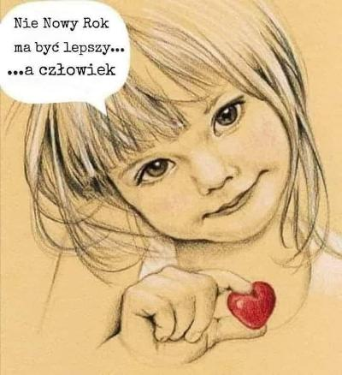

**What has happened since our last meeting on Wednesday**?

* H.R.82 was introduced under the same number by Republican Garret Graves on Jan. 9.
* There was an exchange of emails between Gienek and Leszek Pawlik, President of the Coalition of Polish Americans (CPA) regarding the Retirement Conference in Warsaw. They revealed serious discrepancies in the assessment of the meeting and the exchange was stopped,

**We talked about:**

* YIVO recently announced a series of programs about Polish responsibility for the destruction of Polish Jewry. The program is based on critical theory and cultural critique initiated by Jan Tomasz Gross’s book, Neighbors (2000).
* The Katyń Monument. Bogusława Huang, President and Wojciech Mazur, VP of the Committee for Conservation of Katyn Monument and Historic Objects shared with us the progress of work around the monument and answered our questions. Thanks to their dedication and hard negotiations most of Polonia's proposals were implemented and plans corrected. Jersey City invested 7 million to improve surroundings of the monument. The work supposed to be completed in the Spring. The next goal will be to enter the monument on the list of National Monuments.
* Internet portal dedicated to Polonia’s issues. The idea was refreshed by Krzysiek G. in an email to Zbyszek. There was a long discussion about what it should be like and by whom could be run.
* Meeting with Consul General Zyzak and Honorary Consul Walawender. Jola, who is in the process of arranging the meeting, informed us that it will be postponed closer to February. We repeated our plans for this meeting.

**Following decisions were made:**

* We will help in the preparation of the text that will be on the bronze plague, placed on the monument side on the wall, erected from the Montgomery Street. The text should be written for Americans and should not be a repetition of the text already existing on the base of the Monument (added Andrzej and Krzysiek)
* Jacek is going to ask his Rep. Gerald Connolly(D), VA-11, to reintroduce H.Res.664.
* We will press on legislators to help with restitution from Germany to Poland for WWII crimes.
* According to Krysia there is no need to argue with YIVO’s “research program”.

**Next meeting**: PACT’23 - Thursday, January 19, at 3 PM New York Time via Skype

AGENDA: CPA arguments re Retirement calculations, “Kaz…” book, current events

zk, 1-15-23

**PACT’23 - Meeting #2** Thursday, January 19, 2023 3 – 5:53 PM ET Participated:

Andrzej, Edmund, Gienek, Halina, Jacek, Jurek B., Jola, Krysia, Krzysiek, Ryszard, Zbyszek.

**What has happened since our last meeting on Thursday**?

* Krzysiek Gajda informed that Łukasz Warzecha, an independent journalist, will meet with Polonia in Texas. People interested in inviting him to their place, should contact Krzysiek.
* “Kaz...” will be available in the New York State Libraries Catalog of Books (from Bogdan).
* Leszek Pawlik, President of the Coalition of Polish Americans (CPA) received a call from the office of Archbp. Vigneron, in response to his letter requesting an audience re the liquidation of Seminary at Orchard Lake Schools (OLS). Leszek was informed that the Archbishop was not responsible for closing (temporary) the Seminary only Regents. What Leszek was not told that Vigneron is responsible for the elimination of the Seminary from OLS and what Polonia is trying to prevent.
* Leszek accused the PACT group of not wanting to cooperate with the CPA and of intercepting projects that the CPA decided to work on.
* Jacek notified Frank Spula that Michael McCaul R,10d, TX) – the new chairman of the House Foreign Committee and Senator Bob Menendez (NJ) - the chairman of the Senate Foreign Committee refused to meet with the Polish Deputy Minister of the Foreign Affairs Arkadiusz Mularczyk who seeks US support for World War II reparations from Germany.

**We talked about:**

* A very active PACT member turns 92 tomorrow. We sang “many more years (100 is not enough!) in good health” to Richard, President of the Polish American Congress, Long Island Divisions and a member of several Polish American organizations.
* The Katyń Monument. Irene Guillon sent us a drawing of the 5’ wall facing Montgomery Street. We hope that EPASID can be persuaded to lower the height of this wall to 3 feet.
* PIASA (The Polish Institute of Arts & Sciences of America) founded by Prof. Piotr Wandycz has been taken over by the chosen ones and turned into anti-Polish propaganda. What can we do, Krysia wondered.
* Leszek Pawlik's recent email re the Conference on methods of calculating immigrants pensions in Poland. All aspects were discussed, including why some countries are excluded from the WEP (because their nationals receive a Civic Retirement).

**Following decisions were made:**

* We will send individual letters of support for the PAC-Missouri Division's request to Archbp. Mitchell Rozanski to save the only Polish Parish in St. Louis and all of Missouri.
* Gienek’s proposal will be sent again by Krystyna to the office of Rep. John Larson with a list of participants of the meeting. Looks like they missed what was sent to them in Dec.
* There seems to be a better chance to repeal the WEP in the US than getting Polish officials to comply with Polish law and allowing immigrants to choose how their retirement pensions are calculated.
* Zbyszek and others were asked by Krysia to find out about their Local Human Rights Commission. We could complain to them, for example, about YIVO's discrimination policy.
* We will try to include Helena Knapczyk into the Immigrant Heritage Hall of Fame in Connecticut (listen to her story: [www.youtube.com/watch?v=fgGka9QvI-M](http://www.youtube.com/watch?v=fgGka9QvI-M)).
* Krysia recommended reading carefully the latest PIASA Newsletter: <https://piasa.org/newsletter-vol-3-no-1-january-2023/> :
* We should all read the book “Kaz…” and start spreading the word about it, now (Jola).
* A new chair of Ways & Means Committee became Jason Smith Rep. in Missouri. Gienek will try to get in touch with him and talk about repealing WEP.

**Next meeting**: PACT’23 - Thursday, January 26, at 3 PM New York Time via Skype

AGENDA: reading all reports from meetings in January and commenting zk, 1-21-23

**PACT’23 - Meeting #3** Thursday, January 26, 2023 3 – 6:23 PM ET Participated:

Andrzej, Edmund, Gienek, Halina, Jacek, Jola, Krzysiek, Ryszard, Susanne, Zbyszek.

We welcomed a new person at this PACT meeting:

Ms. Suzanne Mazurczyk, an active member of Polish American Strategic Initiative (PASI) and the Committee for Conservation of Katyn Monument and Historic Objects (CCKMHO).

**What has happened since our last meeting on Thursday**?

* The American Federation of Teachers (AFT) Retirees webinar was held last week. Zbyszek was present and was surprised that at the well-prepared summery of the efforts to repeal WEP/GPO there was NO mention of those who derailed H.R.82, despite overwhelming bipartisan support. The interesting part was about inflation; Cola (Cost of Living Adjustment). A couple of links: [Webinar Recording](https://click.actionnetwork.org/ss/c/oZT1C-8NKsWHlAiWATd-7GmB6sghpYK61xCCPnOOpu6wdaRv7r4rho-Vk8zkfEjJFnH9ziuJUb75j3ZY3c5CYZ684RjWeK3lyrBaI0y7hQY_LKDHA5UKtYE0Dfld9U9ExZu9fyOFih62gNLbKP6cy-3eOdhf6pL4fTB4v9gFz59TBuVK02Rf5ljQ5r9t0Pyto3HGcmDQroBNUKrfYkl33NHQ9KX3GYky8BTjcOC5l4hifLEDQfJCj-7dxxGBSDTI2NEz8qlmmETqDQC4Lza7-w/3t0/Ch0L7lZERx2_ORkgkYEwKg/h0/PsfuJW2t4t589Mgi-DSUEgQ-MGRMEN8mO-9GYRtkBv0) + [WEP Calculator](https://click.actionnetwork.org/ss/c/atcYNHk4Eh2YdGnwBh-YDJMdjUVHaWS8nlRgmuwLksviPn3rHzy7Rux-38ijH1OaaKkiPHYouiKoqBFK1J3RcDNeoYBM_tZnquTaQC2anynHRNTxZIgU24tvjVccp6Cs-F30-uZMVINwtoPjzKK1e_XbdtJf07AbTZgJ0PIZgMzdgClNNBrF2qh_-Kduq64BCFBXzUdcO3VdcTo_xYEMN-yLNnJKMedek3CQ5JuRimUcMmDBR83GWVexDx8pigiLlFNymHnN0nUT0b9coP4gyo7mDpa0qnksuMCcvbs9RfIdssFaA9AuGeYayuVIWzfC/3t0/Ch0L7lZERx2_ORkgkYEwKg/h7/OC6vvU_4pFE03Rdi_XiPqLIal7Ole7B63Zl_Tp3nNas)
* Anna B. sent Zbyszek official requirements for candidates for OLS Regents.
* Committees have been formed at PASI for various tasks
* There has been a major reshuffle at the national office of Polish American Congress: Klara Wisniewska, Office Administrator has resigned and John Czop, Director of Policy Planning was unanimously fired by the Executive Committee at the same time.
* Yesterday (1-.25), Frank Spula was awarded for his activities in Warsaw by “Wspólnota Polska”: <http://wspolnotapolska.org.pl/wiadomosci.php?id=8327>
* Jacek, Gene, Jim and Wojtek J. will meet on Monday with the Ambassador of the RP and the Secretary of State in the Ministry of Foreign Affairs, Arkadiusz Mularczyk.
* Dr. Jim sent a smart request to Rep. McCaul to meet Minister Mularczyk.

**We talked about:**

* This year’s reports from 3 our meetings. Andrzej read them aloud and the participants commented. Bugs that were noticed in the reports, were fixed.
* Katyń Monument - where the 2x3 feet plague should be located, describing what the Monument commemorates. Susanne: on the wall from the Montgomery Street, that is promised to be lowered to ~3 feet, will be a sign “In Memory of Katyń”.
* Requirements to become an OLS Regent which Jola summed up. She emphasized the importance of the letter attached to the resume: “Why I want to be OLS Regent”.

**Following decisions were made:**

* PAC-Missouri will not post a request on ND\_Forum to support their fight to preserve the church in St. Louis. Gienek explained that it was not worth it, because his division never received any help either from National Directors or the Executive Board. Other participants admitted that they had similar experiences.
* Zbyszek reminded participants to send individual letters of support for the PAC-Missouri Division's request to Archbp. Mitchell Rozanski to save the only Polish Parish in Missouri.
* We will not bother contacting Rep. John Larson's office again, because clearly, he is deceiving us into believing that he is in favor to repeal the WEP. Info from Krysia: he resubmitted his bill from last year.
* Gienek has a 3-man team ready to talk to Rep. Jason Smith (MO), chair of Ways & Means House Committee, to repeal H.R.82. We should help prepare the script.
* We will try to find and watch a documentary (recommended) about Erazm Jerzmanowski, once the richest Pole in the US: <https://en.wikipedia.org/wiki/Erazm_Jerzmanowski>.
* Susanne sent us a link to a petition prepared by Waldemar Biniecki re the Seminary at OLS. Those who have not signed it yet are encouraged to do so: <https://www.ipetitions.com/petition/help-us-to-save-ss-cyril-methodius-seminary>
* Donations to CCKMOH, as per e-mail from Celina can be made here: <https://www.gofundme.com/f/committee-for-conservation-of-the-katyn-monument>

**Next meeting**: IOM’23 – Wednesday, February 1, at 8 PM New York Time via Skype

AGENDA: this report will be read and commented on. zk (West Palm Beach), 1-21-23.

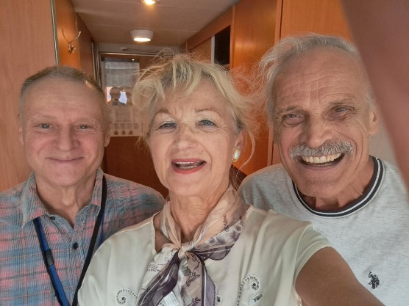**IOM - Meeting #2** - Wednesday – February 1, 2023 8 PM – 10:15 PM New York Time

Participants: Andrzej, Gienek, Jacek, Jan S, Jola, Krysia, Krzysiek G, Krzysiek, Renata, Zbyszek

We welcomed Jan Sołowiej

who joined us for the first time.

meeting with Jurek on a cruise ship (he had a chance to talk to President Trump about history of Poland)

**What has happened since the last Thursday meeting?**

* Jacek organized a meeting with Vice Minister, Arkadiusz Mularczyk at the Polish Ambassy in DC last Monday. Apart from Jacek, there were prof. Wnęk from the Department of State + Presidents of PASI and PASI ED, Wojtek Jeśman and Gene Sokolowski. The matter of reparation from Germany to Poland was discussed.
* Jacek reported that Mr. Mularczyk met with Congressmen: Brad Schneider (R-IL), Joe Wilson (R-SC), James French Hill (R-AR), John ‘Jack’ Bergman (R-MI), Raja Krishnamoorthi (D-IL), Marcy Kaptur (D-OH), Stephen Cohen (D-TN), Joseph Courtney (D-CT), Delia Ramirez (D-IL), Mark Quigley (D-IL) and Senators: Ted Cruz (R-TX), Richard Scott (R-FL), Todd Young (R-IN).
* Zbyszek mentioned: an article in WSJ “Polish repair shop patching up Ukrainians Arms”, (received from Łucja), valuable meeting with Jurek Bogdziewicz in Palm Beach, reparations in “Bibuła” (sent by K.Panek) <https://www.bibula.com/?p=138590>, PASI appointed various Committees, invitation to meet with Consuls re the OLS, article in NDz about Fr. Król <https://dziennik.com/sprawa-przeciwko-ksiedzu-krolowi-zamknieta/> , a new draft of Electoral Law in the Polish parliament (sent by Krzysiek G.), a bipartisan group of 60 House lawmakers introduced a bill on Friday that would require a week of Holocaust education in U.S. public schools, the US Congress decided to send millions to Ukraine for Holocaust survivors and for other purposes (both info from Krysia),.

**We talked about:**

* Compensation for damage caused by Germany during WWII. The Greeks have recently received a compensation from Germany (according to Jacek). Poland never got a penny because under the Soviet control had no say. We discussed how we could help convince Americans to support Polish claims.
* Information about Poland in the US. Terry Tegnazian, President of Aquila Polonica and the Kuryer Polski published by Waldemar Biniecki, recalled Jan. The Aquila company specializes in books based on eyewitness accounts, in English, of Poland in World War II. Kuryer Polski is a continuation of the proud, over 70-year-long tradition of the first Polish newspaper in America by the same name published in Milwaukee until 1962, reactivated as an internet portal in September 2020.

**It was decided**:

* Krysia suggested that we look at Jewish Federations and learn from them.
* Krzysiek G. proposed transforming the Forum-Houston-Polonia website into Forum Polonia. Jacek declared his willingness to help in this project.
* We will use Jacek’s idea to convince politicians to support Polish claims that the main reason why Poland has so far not received compensations from Germany is because Roosevelt sold Poland to Stalin's rule and Poland had no voice of its own.
* To support the Resolution prepared by Dr. Gene Sokołowski, as well as petition.
* Krzysiek G. proposed dissemination of films about Pilecki and “Interrogation”.

**Next meeting:** PACT’22 > Thursday, February 9, 2023 at 3 PM ET via Skype

AGENDA: this and previous report will be read + current events zk 2/5/23

**PACT’23 - Meeting #4** Thursday, February 9, 2023 3 – 5:56 PM ET

Participated: Andrzej, Andrzej P., Edmund, Gienek, Halina, Jacek, Jola, Jurek B., Ryszard, Tomasz Sz., Zbyszek.

We welcomed a new person to this PACT meeting: Tomasz Szymkowiak (from Wroclaw),

Founder & Co-owner of Genealogy Tour <https://www.facebook.com/genealogy.tour>

**What has happened since our last meeting on Thursday**?

* Gienek informed about promising news; Archbishop responded to PAC- Missouri's request: church of St Agata can exist as long as parishioners continue finding Polish priests who will lead it. Gienek thanked everyone who sent letters to Archbp. and helped save their Polish parish.
* Krzysiek G. wrote an article together with Waldemar Biniecki about the potential of Polonia: <https://dorzeczy.pl/opinie/402937/kodeks-wyborczy-polonia-stanie-sie-elementem-polskiego-krwioobiegu.html> . It is worth reminding Polish officials of this and Polish people.
* Jim Mazurkiewicz forwarded the draft Reparation Resolution (prepared by Dr. Gene Sokolowski, President of PASI-EDU <https://pasi-edu.org/>) to Rep. McCaul’s office.
* Krzysiek G. organizes the first meeting on the Forum Polonia portal, Feb.16.
* Zbyszek talked to Władek and Jurek R. about the meeting with Consuls re the OLS.
* Gienek explained in detail, during Monday meeting of PAS H.R.82 Committee, why and how was WEP introduced and why it is unfair especially to Polish immigrants.
* Krysia alerted us that the Center for Polish Studies at the University of Michigan is moving towards an anti-Polish narrative. Their bulletin (Feb.9, 2023) reads: “*We hope to fund one- to three-month research visits to U-M by Polish scholars, journalists, and artists whose work is targeted by the Holocaust law”.*
* Last Saturday, PASI organized a meeting to support Polish WWII compensation claims.

**We talked about:**

* "Genealogy Tour" - Tonasz presented his company. They help find family members in Poland (basic research package costs $250) and organize trips around Poland.
* 3 important questions from Leszek P.: Why is Polonia so week politically in the US, what can we do today to change it + what and how should we work on it in the long term.?
* The US Presidential elections in Florida. Jurek B.: Polonia voted in large numbers.
* Reports from our last 2 meetings read aloud by Zbyszek.
* Fall elections in the PAC. Andrzej mentioned the degradation of PAC’s reputation among Polonia + the need to find not only a good candidate for President but also for VPs.
* Andrzej P. recalled Gordon Black’s achievements in California public schools (a lesson about WWII) and the reaction of Jewish women during Dr. Ewa Kurek’s presentation on Jewish children in monasteries.

**Following decisions were made:**

* Andrzej repeated his idea to suggest to organizations to grant scholarships to Polonia students with the proviso that they must join the organization from which they received money and continue their membership for several years (dues should be symbolic). Also, political science students should be preferred over all others for scholarships.
* Gienek: no Polonia organization should now confuse legislators by submitting its own proposals at this time. We should work with US organizations to repeal WEP/GPO and support reintroduced H.R.82. It seems that the Coalition of Polish Americans does not understand this. Andrzej was asked to obtain info from the CPA Board about their action and explain to them how important is to speak with one voice to achieve the goal.

**Next meeting**: PACT’23 – Thursday, February 16, at 3 PM New York Time via Skype

AGENDA: this report will be read and commented on. zk (Miami Beach), 2-10-23

**PACT’23 - Meeting #5** Thursday, February 16, 2023 3 – 5:44 PM ET

Participated:

Andrzej, Andrzej P., Edmund, Gienek, Halina, Jacek, Jola, Jurek B., Ryszard, Zbyszek.

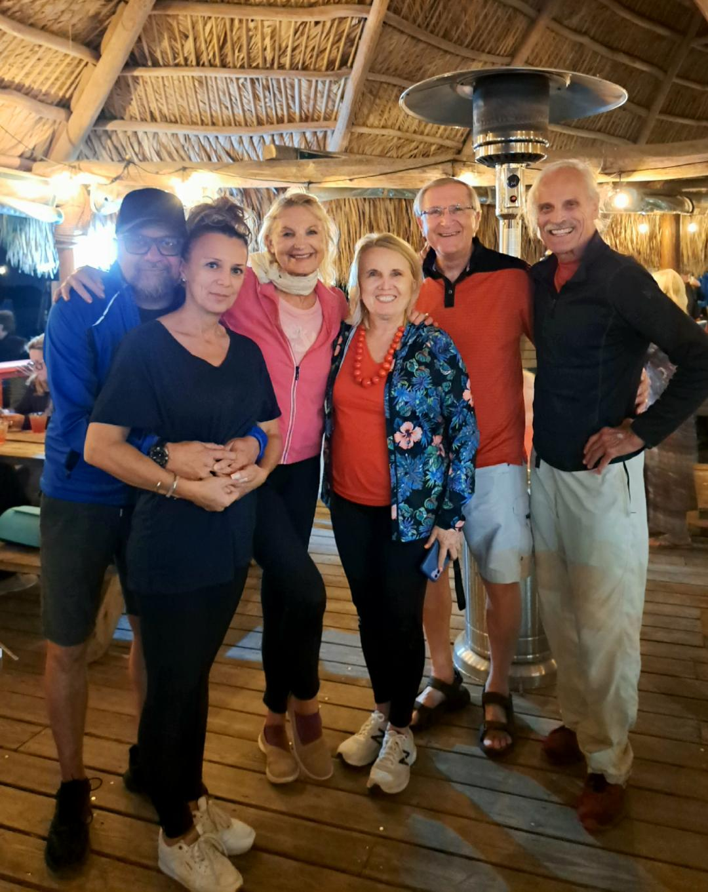

Robert, Edyta, Halina, Anna, Mark, Zbyszek in Sarasota, Florida (Feb.14)

**What has happened since our last meeting on Thursday**?

* Jola informed us about amazing changes regarding the meeting with the Consuls: they do not want to meet with various Polonia organizations, as originally planned, only with the Polskie Lobby and there will be no talk about OLS. The meeting will be held on Tuesday.
* Halina and Zbyszek participated in the 60 Million Congress in Miami Beach from Thursday to Saturday, Feb. 9-11 <https://60mln.pl/pl/> . They talked to many interesting people, including Dr. Marek Chodakiewicz - professor of history at the Institute of World Politics, Andy Gołebiowski - host of the radio show in Buffalo, Dr Bogdan Kotnis – author of the book “Kaz”, Edyta Ślusarczyk and Robert Wachowiak - producents of “Flavor of Poland”.
* Jan Peczkis presented his review of the Polish government 3-volume study on WWII reparations from Germany: <https://www.jewsandpolesdatabase.org/2023/02/11/poland-war-losses-germany-owes-poland-reparations-big-time-definitive-work-poles-and-not-only-jews-suffered-long-term-demographic-losses-zyblikiewicz-and-wnek/>
* Halina and Zbyszek met with Anna Pienkos and Mark, VP of PAC, in Sarasota on Feb.14.
* Zbyszek started reading the book “Kaz” and his initial opinion is very positive.

**We talked about:**

* Details on how to help candidates who are considering running for positions on the Polish American Congress (PAC) Executive Committee.
* A plan for candidates that could help them revitalize the PAC.
* Recent events in Miami Beach: the 60 Million Congress organized by Grzegorz Fryc and the 50th International Polonaise Ball of the American Institute of Polish Culture (AIPC) organized by Lady Blanka Rosenstiel.
* Planned meeting on the creation of the Forum Polonia website (hosted by Krzysiek G.).
* Report from the last Thursday's meeting (read by Zbyszek).

**Following decisions were made:**

* Andrzej will be working on a list of PAC National Directors with their emails and phones.
* Zbyszek will prepare a proposal on how to help candidates in the elections to the PAC EC.
* Zbyszek will ask Krzysiek G. to allow Andrzej and Krzysiek to participate in today's meeting regarding the Polonia Forum website.
* Andrzej P. will send info what Gordon Black has achieved in public schools in California.

**Next meeting**: PACT’23 – Thursday, February 23, at 3 PM New York Time via Skype

AGENDA: this report will be read and commented on. zk, 2-20-23

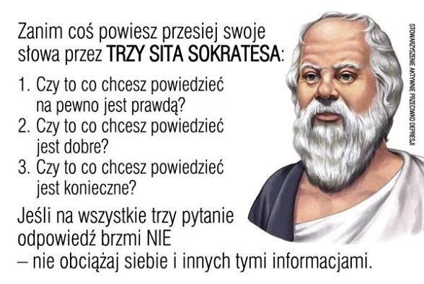

**PCT’23 - Meeting #6**

Thursday, February 23, 2023 3 – 6:11 PM ET

Participated:

Andrzej, Edmund, Gienek, Halina, Jacek, Jan S., Jola, Ryszard, Zbyszek.

**What has happened since our last meeting on Thursday**?

* Gienek informed us that our letters to Archbishop seem to change their thinking, some Parishes will be served by one pastor instead of closing them.
* Jola & Renata met with Consuls on Tuesday and they were told that OLS for Polonia was lost. Only the introduction of Regents with Polish hearts can change the situation.
* Nathan Silverstein, President of the Polish Club at UT organized a meeting with mbassador Brzezinski. Recording from the meeting: <https://youtu.be/AuVaOc4wqVE>.
* A meeting was held on creating the Polonia Forum website (hosted by Krzysiek G.).
* Info: IX World Congress of Polonia and Polish teachers will be held in Toruń, May 26-28.

**We talked about:**

* OLS. What can be done to preserve the Polish character of this institution.
* The report from the last meeting was read and some items extended/discussed.
* The book “Kaz”. Halina likes it. We should start informing our friends about it.
* What was introduced to schools in California. Edmund explained: he was part of the team with Gordon Black (Blachowiak) and prepared info about WWII for schools, emphasizing the Polish experience. He told us about his appearance at the meeting of the Education Council. Jan S.: Kazimierz Braun used the materials prepared by Gordon and made the film Eugenica. Jan also mentioned the film of Mac Felton " Katyń".
* Programs for candidates who decide to apply for PAC ET.
* Criticism of passive Polonia's attitudes and are we able to change them.
* Meeting with Mr. Jacek Rosa from the Ministry of Foreign Affairs will be held on Saturday.

**Following decisions were made:**

* Andrzej will continue to work on the list of PAC National Directors and proposed work on ideas for candidates to PAC ET.
* Zbyszek will learn from Dr. Jim what is the status of the Reparation Resolution.
* We will not try to reintroduce H.Res.664 again. We will wait what will happen with the Reparation Resolution prepared by Dr. Gene Sokolowski.
* Jola will suggest Regents to join the American Archives by Polish OLS Archives.
* To approach Archbishop Vigneron to support Polish regent candidates.
* Andrzej will remind teachers about Katyń Lesson.
* Zbyszek will try to invite Joseph Rej to our meeting next week Wednesday at 8 PM ET.
* Krzysiek: we should continue to look for candidates for Regents. Jola: 3 already applied.
* To mention on ND\_Forum about the upcoming PAC EC elections and time limits will eliminate some officers from the race this year and we should look for replacements.
* Jola will inform Consul Zyzak about a meeting on Restitution of German looted Art.

**Recommended:** President Biden in Warsaw (from Łucja) [whitehouse.gov](http://whitehouse.gov/)

Prof. Chodakiewicz about EU (from Zygmunt): part I <https://twitter.com/Tysol/status/1626355491952795648?t=h5smzm6_C_b_xxM6z6hUQg&s=09>

Part II: <https://www.tysol.pl/a99660-tylko-u-nas-prof-marek-jan-chodakiewicz-peryferie-ue?s=09>

**Next meeting**: IOM’23 – Wednesday, March 1, at 8 PM New York Time via Skype

AGENDA: this report will be read and commented on. zk, 2-26-23

**IOM’23 – Meeting #3**  Wednesday – Mach 1, 2023 8 PM – 11:12 PM New York Time

Participants:

Andrzej, Andrzej P., Gienek, Halina, Jacek, Jola, Krysia, Krzysiek G, Renata, Zbyszek

Every year on March 1, we are celebrating the National Day of Remembrance of Cursed Soldiers. They never gave up the fight for free Poland and we should never forget about their **perseverance and heroism**. We live in different times, but they can still be an example for us; to be active and work on issues important to Polonia and Poland, even if most people are passive and they do not want to get involved. <https://en.wikipedia.org/wiki/Cursed_soldiers>

**What has happened since the last Thursday meeting?**

* Meeting with Minister Jacek Rosa on how Polonia could help convince American politicians to support compensation for Poland for WWII (organized by Krzysiek G. and Jacek last Saturday).
* Meeting of the PASI Committee working on the WEP repealing last Monday.
* Gienek prepared a letter to Rep. Jason Smith and sent it to PASI for comments.
* Yesterday, Krzysiek and Zbyszek participated in a webinar “Diplomacy and restitution of German-looted Art” organized by the Chicago DePaul University.

**We talked about:**

* How we can get a support of American politicians for Poland that is trying to receive compensation from Germany for damages caused by them during WWII.
* Current situation and what to do to revive PAC EC. Jola wanted to know how to bring young people to the PAC Michigan Division. Gienek reminded about the financial assistance of the PAC Division for young people to go to Poland and enable them to meet their peers. He also mentioned the Kościuszko Foundation (KF) and its annual program of youth trips to Poland. Parents are required to be KF members.

The purpose of the trips is to open eyes of young people to the fascinating history, people and landscapes of Poland. Zbyszek added that in Polish Saturday schools there should be a lesson about Polonia organizations, their missions and what they offer.

* The Anti-defamation League (20 US offices). They have 5,5 million for salaries for 400 employees Their professionals hunt for anti-Semitic incidents.
* Progress on WEP repeal. Action to inform Polonia about WEP through announcements in churches. An example of how this can be done was prepared by Rogata Dusza.
* Patriotic Concert in Wallington in 2022 (I recommend listening):

[https://youtu.be/XD2WXvn6Rtc](https://youtu.be/XD2WXvn6Rtc );[Koncert - YouTube](https://www.youtube.com/watch?v=XD2WXvn6Rtc" \t "_blank)

**It was decided**:

* Gienek will consult with PASI his info leaflet on WEP (he emphasized that PASI is the leading Polonia organization on the repeal of the WEP). Polish and English versions should be placed at the entrance of churches which should be our info distribution centers (Andrzej P.). The Polish and American media should also be informed.
* To suggest to Polonia organizations to Invest in young Polish Americans by helping them visit Poland. Prerequisite: parents must join an organization that offers help.
* To educate Reps’ Education Staffers about Poland’s suffering during WWII. This could help us get the Reparation Resolution in the US Congress (Krystyna's suggestion).
* That PAC Missouri will send a letter without additional explanations, prepared by Gienek, to Rep. Jason Smith (R-8d.) who leads Ways & Means Committee, after PASI reviewed it. In 2003,4,9 the Missouri Senate passed a resolution calling on the US Congress to repeal WEP/GPO (this must be mentioned in a letter to Rep. Smith).
* To encourage Polonia to make donation to the Polish American Congress:

<https://www.paypal.com/donate/?hosted_button_id=67NC46YGN85B2>

**Next meeting:** PACT’23 > Thursday, March 9, 2023 at 3 PM ET via Skype

AGENDA: this and previous report will be read and commented + current events. zk 3

**PCT’23 - Meeting #7**

Thursday, March 9, 2023 3 – 6:11 PM ET

Participated: Andrzej, Andrzej P. Edmund, Gienek, Halina, Jacek, Jola, John Cz., Krysia, Krzysiek, Krzysiek G., Zbyszek.

We welcomed a new participant, John Czop.

**What has happened since our last meeting on Thursday**?

* On Friday morning, March 3, there was a webinar hosted by Nathan Silverstein, Founder and President of the Polish Club at University of Texas on the rebirth of Jewish life in Poland. The guest was the CEO of the Jewish Community Center (JCC) in Krakow Mr. Jonathan Ornstein.  <https://www.youtube.com/watch?v=VwxiAs1z2Yo&t=4s>.

**We talked about:**

* Polish Club at the University of Texas. The President's email address is not a university address. Observing their activities, doubts were expressed whether this Club was really Polish, or perhaps it should rather be called Polish Jewish.
* Report No. 6 of the PACT’23 meeting was read and commented on.
* Orchard Lake Schools (OLS). The Polish Institute asks for donations and is open for cooperation. Jola: I hope this is a legitimate request.
* Elections in the Polish American Congress. The term limit may affect the position of the President and a few other people in the Executive Committee this year but only assuming that the time in office is counted before this amendment was approved in 2018. The candidates for the position of President will most likely be: Alicja Kuklińska (Frank's former Secretary and currently Director of the PNA), PAC VP for American Affairs and Secretary, Tim Kuzma and Vice President of PAC, Mark Pienkos. The abilities of each of them and their electiveness were discussed. Reminder: in 2018 the By-laws were amended. The term limit was established for 4 terms, each term of office lasts 2 years.
* Jonathan Ornstein and his description of the Kielce pogrom.
* Difficulties in finding the PAC website and lack of updates.

**Following decisions were made:**

* Krysia and Krzysiek will prepare a plan how to approach the Polish Club. They will cooperate with Andrzej and Zbyszek.
* Andrzej will continue to work on making it easier to find the Katyń Lesson.
* Zbyszek will contact Ms. Jaminska (Misia) and ask her for the NDs list.
* We should all watch the one-man theatrical production “Jan Karski” on PBS TV station (in New York: Monday, March 13 at 9 pm).
* We will continue to explore which positions will be available in the fall PAC EC elections.
* Edmund will continue to search for materials prepared by PAC-North California on WWII, adapted by the California Board of Education.
* John will send info on how we could support arming of Poland, a $24 billion project.
* We should demand the discount that Poland deserves on arms purchases.
* Sending the book, ”Polish society under German occupation” by Jan T. Gross to Silverstein, President of the Polish Club and Ornstein, CEO of Jewish Cultural Center.
* We should organize objections to the Holocaust Education Bill.
* Sending info about Pogrom in Kielce prepared by IPN and “I Saw Poland Betrayed” by Arthur Bliss Lane: <https://en.wikipedia.org/wiki/I_Saw_Poland_Betrayed> , to Silverstein of the Polish Club and Ornstein, CEO of JCC.

**Next meeting**: PACT’23 – Thursday, March 16, at 3 PM New York Time via Skype

AGENDA: previous report and this one will be read and commented on. zk, 3-10-23

**PCT’23 - Meeting #8** Thursday, March 16, 2023 3 – 6:57 PM ET

Participated: Andrzej, Edmund, Gienek, Halina, Jacek, Dr. Jim, Jola, John Cz., Krzysiek, Ryszard, Suzanne and her mom, Zbyszek.

**What has happened since our last meeting on Thursday**?

* Gienek: after consulting with PASI the PAC-Missouri sent a letter to Rep. Jason Smith

(R Mo #8), Chair of the Ways & Means Committee asking for support WEP/GPO repeal.

* Zbyszek visited the website of the Polish Club and was amazed at how active they are.
* Dr. Jim has not received any messages from the staff of Rep. Michael McCaul (R Tx #10). More than a month ago, he sent the draft Resolution on compensation for Poland for WWII written by Dr. Gene Sokolowski, President of PASI EDU. Nobody knows who is monitoring this project. Dr. Jim has not received any instructions on how to proceed.
* Gienek was invited by the Coalition of Polish Americans last Monday to reiterate his position on pensions paid by ZUS and asked to participate in the upcoming meeting with attorney Jerzy Kwaśniewski from Ordo Iuris and Minster Robert Wójcik.
* Krzysiek G. received a set of documents from Minister Jacek Rosa re compensations for WWII. Andrzej will save them on pCloud, so anyone interested will be able to see them.
* Jola: the OLS Regents are due to meet soon. Not a word about accepting new ones.
* Andrzej Burghardt and Dr. Stanisław Śliwowski from PAC New Jersey and Bożena and Andrew Kaminski from PAC DSNY were present at 10th Anniversary of PAC-LI last Sunday. Bożena, VP for Polish Affairs in the PAC EC explained that the term-limit will become effective in 2026 (4x2 years after approval by NDs in autumn of 2018).
* Tomek Kolodziej was elected President of the PAC- Washington DC last Sunday. Jacek was re-elected as Vice President (there are 4 Vice Presidents in this division).

**We talked about:**

* One-man production on PBS “Remember Jan Karski”. Ryszard: the play was over-dramatized: <https://www.pbs.org/wnet/gperf/remembering-jan-karski-utqjbw/14623/> . He met Jan twice and had the opportunity to talk to him. He would characterize him as having three personalities: private, educational and diplomatic. Suzanne noticed that he was only 28 when he met President Roosevelt. Krzysiek was the keenest observer of us all, he pointed out that there was no mention that Karski worked for the Polish Underground State and Szmul Zygielbojm was a member of the Polish Government in-exile.
* Polish Club at the University of Texas. We talked how it was created, about its activities and its 21-year-old founder and President Nathan Silverstein. Jim: he is a very bright, energetic and highly motivated person. The ability to organize meetings with all former Polish presidents and other known personalities will certainly help him in his future diplomatic carrier, if he so chooses. Perhaps he receives advice and support from his Polish mother Dr, Teresa Grabiec Silverstein and his Jewish father (a well-known lawyer living in California). Nathan’s first guest (just after funding the Club in January 2021) was his mother: <https://www.youtube.com/watch?v=kio_YkS5msE>.
* A website for the entire Polonia. Zbyszek did not like the word Hub in the name. Everyone agreed that Polonia Network proposed by Jola. would be more appropriate. We did not have time to discuss the outline of Waldemar Biniecki and Krzysztof Gajda’s website.

**Following decisions were made:**

* Look for Polish Clubs in colleges/universities in the area where we live (Jim’s request).
* Contact local Polish Schools and help teachers use the Katyń Lesson.
* We will not intervene at the Polish Club in UT (it is a registered organization, independent of the university). We can only warn Polonia against its extreme left-wing politics.

**Next meeting**: PACT’23 – Thursday, March 23, at 3 PM New York Time via Skype

AGENDA: previous 2 reports and this one will be read and commented on. zk, 3-21-23

**PACT’23 - Meeting #9** Thursday, March 23, 2023 3 – 7:07 PM ET Participated:

Andrzej, Andrzej P., Gienek, Halina, Jola, Krysia, Krzysiek, Ryszard, Tomek, Zbyszek.

*“With our future ahead of us and the ancestors besides us, there’s nothing we can’t do.”*

**What has happened since our last meeting on Thursday**?

* Andrzej, Krzysiek, Staszek and Zbyszek met yesterday (Wednesday) to discuss the activities of the Polish Club at UT and the search for contacts with Polish Clubs.
* Zbyszek: in an interview on NPR, with a Democrat and a Republican both stated, in the context of the 20th anniversary of the war with Iraq, that Germany is the US greatest ally.
* Gienek told us about a new, it seems, positive agreement between the foreign ministers of Poland and Israel regarding visits of Israeli youth to Poland.
* Gienek was invited by the Coalition of Polish Americans last Monday to reiterate his position on pensions paid by ZUS and asked to attend an upcoming meeting with attorney Jerzy Kwaśniewski from Ordo Iuris. Gienek sent the info material before the meeting. He was surprised that the meeting was canceled 5 min before the scheduled time and he was notified by an e-mail 5 min before the next one when he was not present at home.
* Tomek resigned from the Presidency of PAC-Ohio (his term has expired). We all hope that the Division will not be resolved. We should use our connections to help them.

**We talked about:**

* Reports IOM’23 #3 and PACT’23 #7 were read and commented on.
* Gienek: WEP does not apply to those whose pension is calculated using the totalization method. All those who worked less than 35 years are punished, so why WEP?
* Exchange of scouts, high school and university students between the US and Poland. We spent a lot of time on it. Gienek stressed that the future of relations between countries is at stake. Consul General in Chicago, Dr. Paweł Zyzak is interested in this project.
* The Copernicus Center for Polish Studies at the University of Michigan (Jola and Krysia).
* Again, about the Polish Club at UT.
* Tomek: read the books (if you can get them): “Byłem szpiegiem” and “Gideon’s spies”.
* Again, about the elections to the PAC EC.
* Distribution of the Katyń Lesson. Zbyszek would like to know how many teachers used it.
* The uniqueness of the Constitution of May 3rd. Andrzej P.: it should be emphasized that the privileged class gave rights to others without a fight, as happened in other countries.

**Following decisions were made:**

* Gienek will call the office of Rep. Jason Smith (R Mo #8), Chair of the Ways & Means Committee, to see if they have received the PAC-Missouri’s letter re WEP/GPO.
* At Wednesday's meeting about The Polish Club, Andrzej, Krzysiek, Staszek and Zbyszek decided to meet Nathan Silverstein anyway and prepare some questions.
* Andrzej P. will find out how the internet was installed in the house in Portland.
* It would be good to prepare info about Polonia organizations for Polish Saturday Schools. Andrzej suggested that we prepare a leaflet that could be useful for parents and students.
* PAC-LI will inform local Reps about WEP using a letter prepared by PAC-Missouri.
* Petition prepared by PASI re WEP repeal should be distributed and signed by us.
* Andrzej P. will try to find materials on WWII adopted in California schools in the 90's.
* Andrzej, Krzysiek and Zbyszek will work tomorrow on a message for teachers reminding them about the Katyń Lesson and that it was now saved in a more open format.
* To help Polonia youth to visit Polish youth by motivating organizations to get involved.
* We should find out if Dr. Zyzak could help with youth exchange.
* To prepare a leaflet for congressmen on reparations to Poland for WWII damages.
* If necessary, Andrzej will organize additional workshops on how to use the Katyń Lesson.

**Next meeting**: PACT’23 – Thursday, March 30, at 3 PM New York Time via Skype AGENDA: previous report and this one will be read and commented on.

zk, 3-26-23

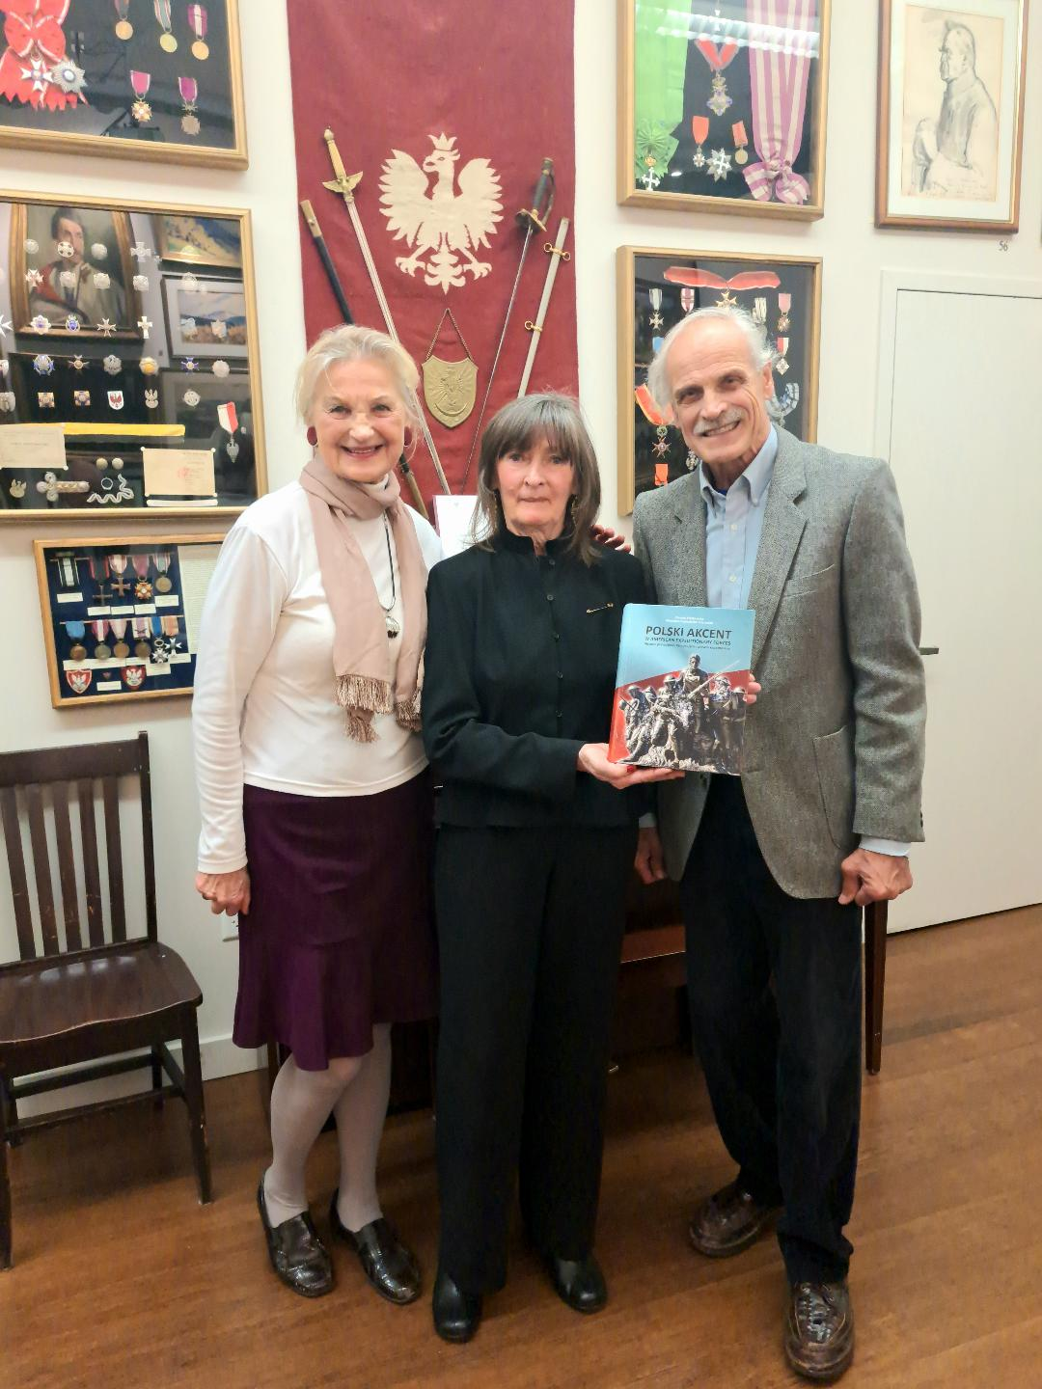

**PACT’23 - Meeting #10**

Thursday, March 30, 2023 3 – 6:13 PM ET

Participated:

Andrzej, Andrzej P., Bogusia, Halina, Edmund, Jola, Krysia, Krzysiek, Wojtek M., Zbyszek.

**What has happened since our last meeting on Thursday**?

* Dr. Andrzej Prokopczuk sent MODEL CURRICULUM FOR HUMAN RIGHTS and GENOCIDE for California Department of Education created 2-6-2003, This document was prepared by Gordon Black (3rd generation), Edmund Lewandowski and Teodor Polak (Warsaw Uprising and a surgeon) and accepted by the Board of Education in California.

Info about Teodor: <https://polishmusic.usc.edu/newsletter/dr-teodor-polak-in-memoriam/>

* Last Saturday, Halina, Łucja, Ela P., Ryszard and Zbyszek took part in the opening of a new military exhibit and books presentations at the Polish American Museum. Krzysztof Szczerski, Ambassador to the UN gave a lecture on the war in Ukraine.
* Last Sunday, a very moving play about famous star, Hanka Ordonówna was staged at the Kościuszko Foundation. <https://pl.wikipedia.org/wiki/Hanka_Ordon%C3%B3wna>
* Last Tuesday, Halina and Zbyszek attended a meeting with the author of “Polski Akcent w American Expeditionary Forces”, Dr. Danuta Piątkowska at the Piłsudski Institute.

**We talked about:**

* Bogusia Huan and Wojtek Mazur (Chairman and Vice Chairman of The Committee for the Conservation of the Katyn Monument & Historic Objects) presented discrepancies in a recently email from Wojtek Jeśman regarding the Katyń Monument and the actual situation. Words of appreciation were expressed for the fight and perseverance in correcting the plans to transform surroundings of the Monument. Spreading inaccurate and unverified info harms those who got involved in the protection of the Monument. Cars will not be parked near the Monument, as it was before. So far, only the lowering of the wall and enlargement of the two entrances from the Montgomery Street have not been achieved. The monument will be cleaned. The cost of beautifying the Monument's surroundings was $7.5 million. Interview with Mr. Wojtek Mazur: <https://kuryerpolski.us/pl/Page/View/wojciech-mazur-wywiad>
* The PACT’23 Reports #7 and #8. They were read and commented on.
* Piątkowska’s book and the merits of legendary heroes: Gabby Gabreski and Matt Urban. Polonia during WWI constituted 3% of the population but there were 10% of them in the US Army (~250 000 soldiers). In total, 115 k Americans died. 45 k, in accordance with the wishes of the families were exhumed and transported to Hoboken in sealed metal coffins. There are 6 cemeteries in France and 1 in Belgian and 1 in England, very well maintained.
* We make decisions about actions, but do not implement all of them, especially the more serious ones. We need to limit on empty conversations and concentrate on moving our ideas forward.

**Following decisions were made:**

* Andrzej, Jola, Krzysiek and Zbyszek will work tomorrow (Friday) on a list of projects that PACT group is able to implement.
* Two events will take place at the Katyń Monument in Jersey City: April 1 (Saturday) and April 30 (Sunday). Those who can, are encouraged to participate.

**Next meeting**: IOM ’23 – Wednesday, April 5, at 8 PM New York Time via Skype proposal of AGENDA will be sent

zk, 4-04-23

**IOM’23 – Meeting #4**

Wednesday – April 5, 2023

8 PM – 10:59 PM New York Time

Participants: Andrzej, Andrzej P., Dianne, Gienek, Halina, Krzysiek, Ryszard, William, Zbyszek

We welcomed a new participant, William Adasiewicz, VP of PAC North California.

**HAPPY EASTER**

**What has happened since the last Thursday meeting?**

* Last Friday (March 31), Fryderyk Darmmont 100 birthday was celebrated at the Polish & Slavic Center. Adrian Kubicki, Consul General spoke and a great concert took place. Slavic Arts Ensemble performed. Christina Tyszkiewicz imitated Hanka Ordonówna.

The Polish American Photo Club presented impressive works by its members.

* Gienek has not received a reply from Rep. Jason Smith after he sent him a letter three weeks ago and called his office a week ago.
* Andrzej participated in the celebration of the anniversary of the Katyń massacre at the Memorial in Jersey City. Consul General Adrian Kubicki spoke. Children from the Polish Saturday School at the church St Casimir gave an impressive performance and the “Aria” choir sang. He shared his observations and the photos he took. It was attended by over 100 people gathered on the eastern side of the monument. According to Andrzej, the overall “beautification” of the surroundings is acceptable with the exception of a 5-feet wall to the west which must be removed.
* Andrzej P. learned that a router is installed on each floor of a Portland house, so reception throughout the house was excellent.
* Halina informed that the book “Obława Augustowska” was translated and printed.

**We talked about:**

* Bill is a 3rd generation Polish American. He introduced himself, and attendees told him about themselves. He is 81 and still working. We were wondering where we can find and reach those who feel Polish. Andrzej P. suggested that we search among the parents of children from Saturday Schools and among various Polonia events.
* PACT’23 Report #8 was read and commented on.
* Dianne noted in the 2023 OASDI Trustees' Report the importance of immigrant contributions to the Soc. Sec.: <https://www.ssa.gov/oact/TR/2023/index.html>
* First draft of the Project plan. The following were proposed as members of the Board of National Polonia Foundation: Dr. Marek Rudnicki, Dr. Stanisław Śliwowski, Rita Cosby, Richard Brzozowski, Gordon Black, John Cebrowski, Dr. Jim Mazurkiewicz.

**It was decided**:

* Decisions taken at previous meetings and not implemented will be included on the list of PACT projects.
* Gienek’s PAC-Missouri Division will send letters to all Congressmen and Senators in its state asking them to support the repeal of the WEP/GPO and will visit Rep. Smith.
* Andrzej proposed asking teachers for comments on the Katyń Lesson.
* An appeal will be sent to the Consulates to support the book “Augustów Roundup”.
* To write a letter to US corporations, with the help of John Cebrowski, informing them about the possibility of advertising on PBS during the II edition of “Flavor of Poland”.

**Next meeting:** PACT’23 > Thursday, April 13, 2023 at 3 PM EST via Skype

AGENDA: this and previous report will be read and commented on. zk 4/7/23

**PACT’23 – Meeting #11**  Thursday – April 13, 2023

3 PM – 5:45 PM New York Time

Participants:

Andrzej, Andrzej P., Gienek, Halina, Jacek, Jim, Jola, Jurek B., Krzysiek, Ryszard, Zbyszek

Reminder: PACT’ is an agreement between organizations and individuals to meet, exchange info and work together on chosen projects.

**What has happened since the last Thursday meeting?**

* PASI asks for donations to continue the lawsuit against Jersey City and its mayor, Steven Fulop who issued, a controversial for Polonia permit, to a developer to make the area around the Katyń Monument more attractive.
* Andrzej, Krzysiek and Zbyszek prepared a draft of questions for the meeting with Nathan Silverstein, President of the Polish Club at UT.
* Halina described the annual Easter celebration by the Jagiełło Monument in the Central Park which took place last Sunday. Krzysiek wished that a similar Polonia gathering would also be organized in Chicago.

**We talked about:**

* Meeting with Nathan Silverstein, President of the Polish Club at UT. Dr. Jim liked the idea of the meeting and the questions prepared by Andrzej, Krzysiek and Zbyszek. According to him such a meeting should be mutually beneficial.
* “Flavor of Poland” series II. Krzysiek eloquently explained what was needed to raise funds specifically from advertisers who could support this unique project that positively promotes Poland on PBS stations across America. He also read what he would advise Halina to send to John Cebrowski to help reach American companies.
* IOM’23 Report #4 and PACT’23 Report #9. The reports were read and commented on.
* OLS. Jola told us about well-known events once organized by Polonia in OLS.
* Preparations for the elections in Florida in the Republican Club and the flood in Fort Lauderdale. Jurek B. shared with us info from Florida. ½ meter of rain fell in 20 hours causing the airport to close.
* Katyń Monument. Krzysiek rightly explained to Gienek that there is no fight, there are two approaches to the “beautification” project. It was discussed whether the lawsuit should continue and what is its purpose now, after positive changes of plans have been obtained. Most participants understand that the only problem is the 5-foot wall off the Montgomery Street which should be lowered to 3 feet or even better, removed.
* Internet booster. Jacek and Andrzej informed us how to improve reception at home.

**It was decided**:

* Zbyszek is going to send Nathan Silverstein an invitation to meet with some of us.
* Gienek: his PAC division will contact the offices of all 8 congressmen in Missouri re WEP. A thank you message will be sent to 3 Reps for their support of H.R.82.
* Andrzej: an email will be sent to teachers asking for comments on the Katyń Lesson.
* Halina will write an email to John Cebrowski corrected by Krzysiek, to help us reach potential American companies that would be interested in advertising in PBS during the II edition of “Flavor of Poland”.
* Andrzej suggested to prepare a leaflet for distribution what advertisers can receive for a certain amount of $$ if they decide to support the II edition of “Flavor of Poland”.
* Jurek B. may meet a businessman over the weekend and try to mention possibility of advertising in PBS.

**Next meeting:** PACT’23 > Thursday, April 20, 2023 at 3 PM EST via Skype

AGENDA: this report will be read and commented on + current news zk 4/18/23

**PACT’23 – Meeting #12**  Thursday – April 20 2023 3 PM – 6:10 PM New York Time

Participants: Andrzej, Gienek, Halina, Jacek, Jurek B., Jurek R., Ryszard, Tomek, Zbyszek

**What has happened since the last Thursday meeting?**

* Today we learned that a few weeks ago, Minister Anna Schmidt and Robert Wójcik representing the Polish government met in Warsaw with Jerzy Kwaśniewski, the President of Ordo Iuris and another lawyer. They allowed only Leszek Pawlik, President of the Coalition of Polish Americans to join via Zoom. It was revealed that an agreement was signed between Poland and the US in which the Polish side committed itself to subject Polish immigrants to the WEP contrary to Polish law.
* On Tuesday evening, Halina and Zbyszek attended a fundraiser event for Jake Scheiner (29 years old former Tom Suozzi staffer for 10 years) in a restaurant in Lynbrook. The minimum donation was $100 per person. Around 100 people attended and he raised over $13,000. Jake, whom we know well, is running for Nassau County Legislature. He gave a stunning speech in which he emphasized that he would focus on lowering taxes, fight crime and better quality of life. We went to meet with Tom Suozzi.
* On Tuesday evening, Ryszard listened to a webinar on the Katyń Massacre hosted by Dr. Halina Piórkowska at Columbia University. Ryszard complained about the sound quality and unclear message. His opinion was similar to others who had opportunity to listen. Here is the link: <https://www.youtube.com/watch?v=8ZMCtHuVEKY>
* Monday, Zbyszek sent an invitation to Nathan Silverstein to meet.

**We talked about:**

* Why young Americans of Polish descent are not involved in political life.
* The Ray Madden Commission for the Katyń Massacre. Here are some details:

<http://pamietamkatyn1940.pl/en/blog/historia_zbrodni/komisja-maddena-2/>

Jurek R. told us how the Polish communists made fun of American Polonia that from the beginning believed that the crime was committed by the Russians. Jurek R. was present at the meeting during which Russian President, Boris Yeltsin apologized and for the first time made documents available for researchers.

* Orchard Lake Schools (OLS). Jurek R. spoke about upcoming events and some details about Fr. Król’s case. There are 3 fewer Polish regents than non-Poles.
* Radio Rozmaitości (Varieties) WNZT 690 AM. Jurek R., the host of the program invited us to listen it free of charge on the internet every Saturday from 9-11 AM: <https://onlineradiobox.com/us/wnzk690680am/?cs=us.wnzk690680am>
* Jerusalem Post comments on the 80th anniversary of the Warsaw Ghetto Uprising. The presidents of Israel, Germany and Poland met in Warsaw (all info below from Jurek R.).
* 550th birth anniversary of Mikołaj Kopernik and events in Detroit and Canada.
* 52 new tombstones for Blue Army veterans. The idea of Harietta Nowakowski (daughter of soldier of Gen. Józef Haller). Józef Majcher (Regent), Fr. Król and the IPN were also working on it. On June 17, President Duda will come to Detroit for this special event.
* Kazimierz Pułaski from the 1939 World’s Fair in Queens, New York , is in Detroit (!).
* Holly Mass on Sunday (April 23) will be celebrated in the Church of St Augustine in Detroit at 5PM for the Katyń Massacre and the Smoleńsk Disaster. On April 25, the Museum of Communism in DC will commemorate those events.
* PACT’23 Report #11 was read and commented on.

**It was decided**:

* Gienek asked all of us to send e-mails and letters to Rep. Jason Smith asking for support in repealing the WEP/GPO.
* Andrzej Krzysiek and Zbyszek will ask teachers for comments on the Katyń Lesson.

**Next meeting:** PACT’23 > Thursday, April 27, 2023 at 3 PM EST via Skype

AGENDA: this report will be read and commented on + current news zk 4/21/23

**PACT’23 – Meeting #13**  Thursday – April 27 2023 3 PM – 6:37 PM New York Time

Participants: Andrzej, Andrzej P., Edmund, Gienek, Halina, Dr. Jim, Jola., Krzysiek,

Krystyna, Ryszard, Zbyszek

**What has happened since the last Thursday meeting?**

* Dr. Jim has had a very busy last week. He took his 25 fellows to several meetings with Ted Cruz, Texas Senator, Adrian Kubicki, Consul General in New York, Michael McCaul Chair of the House Foreign Affairs Committee (R. TX. D.10), officials from the Polish Ambassy in Washington DC. The talks also concerned the Polonia issues.
* Gienek: a letter was resent to Rep. Jason Smith, Chairman of the Ways & Means Committee. This time, after a call to his office, the staffer confirmed receiving it. PAC- Missouri sent letters to other 7 congressmen and 2 senators in its state. They thanked 3 of them for sponsoring H.R.82 and asked 4 to become co-sponsors.
* Edmund met PiS sympathizers around the world via the internet (only 15 people connected) . Justyna Kuryluk organized this virtual meeting.
* Halina mentioned the last Sunday meeting of PAC-LI members. Among other things, the situation regarding Polish Studies at Colombia University was brought up. Important Polish matters, are not presented. The Department of Polish Studies was founded by private donors from the U.S. and Poland in the late 2000s. The money raised was donated to Columbia University, which manages the fund. The donors have no control over the ways in which the funds are spent and who becomes the president. It was discussed, whether Polonia could get involved in the choice of the rector of Polish Studies. <https://www.pol-int.org/polish-studies-blog/expanding-the-horizon-interview-with-malgorzata-mazurek-columbia-university>

**We talked about:**

* Edmund went to Hawaii this time. He connected with us from Honolulu and told how easy is to go around Oahu by public transportation. They found a nice place to stay on the eastern outskirts of Honolulu for only $45 a night.
* Upcoming elections in Poland. Why despite the implementation of important projects by PiS this party does not have a strong support, as one might expect. Edmund: professional anti-PiS propaganda falls on fertile ground in Poland. Gienek and others warn that an online appeal for more polling stations was spread by the opposition.
* PACT’23 Report #12 was read and commented on.
* Gienek once again explained the correlations between the method of calculating the Polish retirement and the WEP. He also told us how Polish courts work. The best solution would be to repeal of WEP. Let's focus on that and end fruitless negotiations with Polish officials.

**It was decided**:

* Zbyszek reminded Gienek’s idea to send a letter by all PAC divisions to Rep. Jason Smith asking for support of H.R.82.
* Krzysiek convinced us not to send e-mails to teachers asking if they were using the Katyń Lesson and to send their comments. Let's not forget to do it next year. Now it is too late (the anniversary of the Katyń Massacre falls on April, May).
* Brochures about Jan Karski and Tadeusz Kościuszko will be sent to Dr. Andrzej P.
* Krzysiek: the priority for our group must be finding money for the 2nd edition of “Flavor of Poland”. We need to find people who know how to reach marketing advertisers.
* We should prepare a set of resolutions: H.Res.664, modified H.Res.664 w/ addition of clauses on reparations, the WWII reparations resolution and ask Zach, who works for Rep. McCaul, which one has the best chance to be accepted. In addition, it is worth returning to the original Katyń Resolution – now is a good time for it.

**Next meeting:** IOM’23 > exceptionally on Thursday, May 4, 2023 at 8 PM EST via Skype

AGENDA: this report will be read and commented on + current news zk 4/28/23

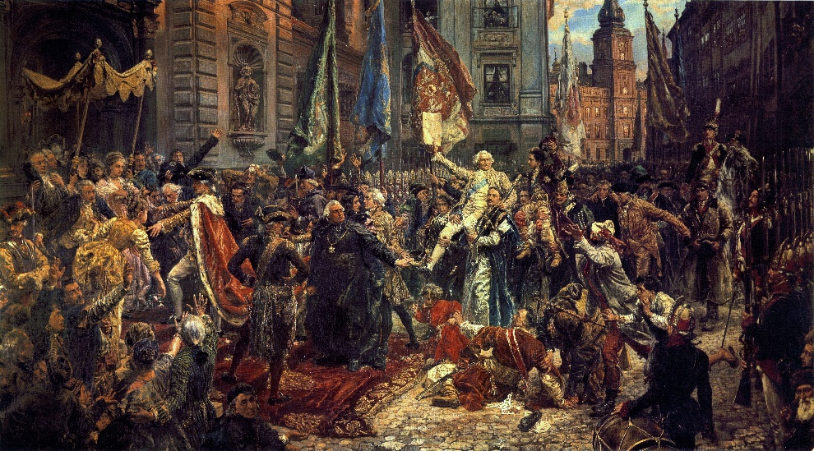

**IOM’23 – Meeting #5**  Thursday – May 4 2023 8 PM – 10:59 PM New York Time

Participants:

Andrzej, Gienek, Halina, Jacek, Jola., Krystyna, Krzysiek, Zbyszek

Painting by Jan Matejko

**What has happened since the last Thursday meeting?**

* Zbyszek led the Katyń Lesson at St. Hedwig School in Floral Park last Saturday.
* Andrzej attended the event at the Katyń Monument last Sunday. Despite the heavy rain ~80 people showed up. He met Ania Tracz from the Board of “Centrala Polskich Szkół” who thanked him on behalf of the teachers for remaining about the Katyń Lesson.
* Krysia was shocked at how undemocratic the By-Laws of the Polish Club at UT are.
* Krysia attended the annual May 3rd Constitution celebration at the Connecticut State Capitol. She met teachers of Polish Saturday Schools and was surprised that none of these teachers work in the American education system.
* Andrzej r recommended listening to Patryk Jaki's speech: <https://twitter.com/SolidarnaPL/status/1653756367595876352>
* Gienek told us that Republican Rep. Ann Wagner diplomatically rejected the PAC-MO’ appeal to co-sponsor H.R.82 (she did the same at the previous session of Congress).

**We talked about:**

* Computers and programs, systems and pCloud. Half an hour was spent on this. Jola proposed to organize a separate meeting devoted to these issues.
* Educational issues, including Silverstein’s essay. An hour was spent on this.
* How Polish children are treated by their peers. Halina and Jola presented what their children experienced. Some participants were surprised to hear about teachers distorting history and some students use it to bully their classmates. Halina mentioned a survey conducted by one of the teachers about what other people think about your Polish background and got the answer that “they think that we are stupid”.
* PACT’23 Report #13 was read and commented on.

**It was decided**:

* Zbyszek and Halina were invited by a Polish School to give a speech to graduates this Saturday but they will not receive any advice as there are more important priorities.
* Krzysiek reminded us that our priority is to combine H.Res.664 and the proposed Reparation Resolution. Andrzej Jola, Krzysiek and Zbyszek will meet tomorrow at 3 PM, compare their proposals and choose the best clauses for this hybrid resolution.
* The topics “Why should I be proud of my Polish heritage” and “How should I respond to ant-Polish disinformation” are too complicated and we will work on them in the future.
* No PAC division sent a letter to Rep. Jason Smith regarding the repeal of WEP/GPO. It was reminded that it is not difficult to do this. Gienek’s letter may serve as an example.
* Krysia will prepare an assessment of Silverstein’s essay.
* We should warn Dr. Jim who is behind the Polish Club at UT.

**Next meeting:** PACT’23 > Thursday, May 11, 2023 at 3 PM EST via Skype

AGENDA: this report will be read and commented on + current news zk 5/6/23

 **PACT’23 – Meeting #14**  Thursday – May 11 2023

3 PM – 5:43 PM New York Time

Participants:

Andrzej, Gienek, Halina, Jacek, Jola, Jurek B., Krzysiek,

Krystyna, Zbyszek

**What has happened since the last Thursday meeting?**

* Friday, as planned Andrzej and Zbyszek worked on a hybrid Resolution combining selected clauses from H.Res.664 and Reparation Resolution prepared by Dr. Sokolowski. Krzysiek made final corrections.
* On Saturday, Halina had a 30 min class at the local School for graduates. Its purpose was to prepare students to face future challenges, hence the titles “Why should I be proud to be Polish” and “How should I respond to anti-Polish disinformation”.
* On Sunday, members of PAC-LI participated in the May 3rd Constitution Celebration at Polish Home in Glen Cove. There was singing and recitation by children and adults.
* On Wednesday, Zbyszek sent to Dr. Jim a new proposal and Reparation Resolution, asking him to forward it to the office of his Rep. Michael McCaul. We want to know which resolution is more likely to be introduced and be accepted by Congress.
* On Wednesday evening there was a Town Hall meeting with Donald Trump. The host was CNN. Halina, Jola and Zbyszek liked the President’s calm behavior and answers.
* Wojtek J. noted that Minister Mularczyk’s report had been removed from the PAC website. He wrote a letter to Frank Spula, President of PAC, asking about the PAC leadership's position on reparations. So far, following divisions have signed the letter: Long Island, New Jersey, Massachusetts, Michigan. Andrzej recalled his appeal to PAC-EC sent on April 12 via PAC\_ND (after the visit of Minister Arkadiusz Mularczyk).
* Krysia read the By-Laws of the Polish Club in UT which are surprisingly undemocratic.

**We talked about:**

* Compensation for WWII. Not to 70 countries, as Dr. Gene Sokołowski wrote in his Draft Resolution, but to about 19: <https://en.wikipedia.org/wiki/World_War_II_reparations>
* Political awareness of the 2nd and older generation of Polonia. Many feel emotionally attached to Poland, but do not know the nuances of history and today’s behavior of some people and organizations. This long discussion began with feedback on Nathan Silverstein's essay. Gienek: Dr. Jim was impressed by Nathan's interest in Polish affairs and his energetic activity, not noticing in which direction he was heading. A worker, the former leader of Solidarity, who became President was also mentioned.
* A Russian rocket capable of delivering nuclear weapons landed near Bydgoszcz.
* IOM’23 Report #5 (from the last week meeting) was read and commented on.

**It was decided**:

* Zbyszek will send to Dr. Jim a replacement for the clause that says in the Resolution that 70 countries received reparations. The new clause will not contain a number.
* Andrzej, Krysia, Krzysiek and Zbyszek will meet Monday at 7:30 PM and will work on information material for Polonia on various factions and tendencies in Poland, past and present. Krysia and Andrzej emphasized that we must be specific and not spend too much time on this topic. Zbyszek was skeptical whether it could be done so easily.
* Krzysiek: Captain Witold Pilecki should be included in the list of great figures of Polish culture and history. His legend should be built and spread; volunteer to Auschwitz murdered by the communists after the war. No other nation has such a hero.

**Next meeting:** PACT’23 > Thursday, May 18, 2023 at 3 PM EST via Skype

AGENDA: current news + this report will be read and commented on zk 5/14/23

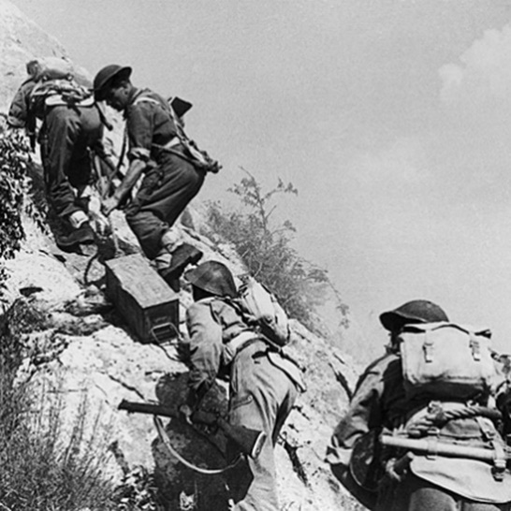 **PACT’23 – Meeting #15**  Thursday – May 18, 2023

3 PM – 4:43 PM New York Time

Participants: Andrzej, Gienek, Halina, Jacek, Jola, Krzysiek, Ryszard, Tomek, Zbyszek

the hardest battle of WWII

On May 16, soldiers of the Polish II Corps launched one of the final assaults on German position.

On May 18, the Polish flag appeared on the ruins of the monastery.

**What has happened since the last Thursday meeting?**

* Zbyszek sent Dr. Jim the clause to the proposed Resolution which will replace the one that says 70 countries have received reparations. Dr. Jim sent it right away with a personal message to Zach, a staffer of Rep. McCaul.
* Zbyszek proposed the following outline for the project of informing Polonia:

What is worth knowing about the past and present Poland.

1. Social and political systems in Poland
2. Constitution of May 3 and Targowica
3. Partitions and Independence
4. Poland before WWII and after
5. The "Solidarity" movement
6. Round table negotiations
7. Leaders and parties
8. Timeline of events (next to American for comparison)
9. Media

* On Monday Andrzej, Krysia, Krzysiek and Zbyszek supposed to meet and start working on info for Polonia. Krzysiek was unable to join. After a few minutes the meeting ended. Zbyszek's idea was rejected. It was decided that those who want to be well informed can do so on their own.
* PAC- Missouri has not received a response from Rep. Jason Schmidt, they will call him.
* PAC-LI sent a registered letter to Rep. Schmidt re. H.R.82.

**We talked about:**

* A new Republican congressman in Tomek’s district and his involvement.
* Informing Polonia. Krzysiek agreed with Zbyszek that it was important. If we do not, someone else can mislead them and take advantage of them (e.g., Nathan Silverstein)
* Pension supplement. Jola: people involved in anti-communist opposition are eligible. Gienek explained that this applies to those whose pensions are less than $2700.
* Solidarity and Freedom Cross. Jola’s husband has been notified about receiving it.
* Co-sponsors of bills that would eliminate WEP. Gienek: 264 Congressmen cosponsor H.R.82 in the House and 44 Senators cosponsor S.597. Most are Democrats.

**It was decided**:

* Jola will meet with Marek Magierowski, the Polish Ambassador in the US. She will ask him if Polish officials know, what Polonia organizations to talk to. Also, whether he knows that a trial is underway re the Katyń Monument.
* PAC-Missouri will call the office of Rep. Jason Smith re H.R.82.
* PAC-LI will once again visit the Polish School next Saturday to present graduates with laminated leaflets about Kościuszko and important Polish figures and maps.

**Next meeting:** PACT’23 > Thursday, May 25, 2023 at 3 PM EST via Skype

AGENDA: current news + this report will be read and commented on zk 5/21/23

**PACT’23 – Meeting #16**  Thursday – May 25, 2023

3 PM – 5:54 PM New York Time

Participants: Andrzej, Andrzej P., Gienek, Halina, Jacek, Jola, Jurek B., Krzysiek, Ryszard, Szymon, Wojtek M., Zbyszek

We had a guest, Mr. Szymon Tolak representing the Polish Cultural Foundation in Boston.

**What has happened since the last Thursday meeting?**

* On Saturday, Zbyszek and Halina, delivered as planned, a laminated "Kościuszko" leaflet with additional info tor Saint Hedwig's School graduates, in Floral Park.
* President of CPA announced, as suggested by Dr. Krystyna Zamorska, the need to establish a team that would deal with the issues of “Polish Studies”. Walter Golebiewski and Alicja Pierzchała want to be in this new working group.
* On Monday, Halina sent to Dr. Andrzej Prokopczuk, President of PAC-North California, a leaflet about Kościuszko and 5 copies of comics about Jan Karski.
* Tomasz Kołodziej, President of PAC-Washington DC, sent an email to Frank Spula, President of PAC via ND\_Forum referring to a letter from Wojciech Jeśman, President of PASI, asking about PAC's position on reparations for Poland and why this issue was removed from the PAC website.
* Tomasz Kołodziej also sent a link to a documentary movie about Poland, he received from the Austin Polish Society in Texas and suggested that it could be shown to Americans: <https://www.youtube.com/watch?v=SYGVZJhkcQU>
* John Czop sent a warning about the reappearance of the anti-Polish Sun newspaper.
* Jola spoke with Ambassador Marek Magierowski who came to Detroit to meet local Polonia leaders. At our request, she asked him among other things, whether Polish officials know, which Polonia organizations are worth talking to. The Ambassador promised to answer (she gave him apart of her, also Andrzej and Zbyszek’s emails).
* Gienek informed that another letter had been sent to Rep. Ann Wagner with additional info and a request for a clear answer on the repeal of the WEP.

**We talked about:**

* Proposal to establish a national holiday on May 30 to commemorate “Nihil Novi”. Szymon Tolak, our guest presented this idea and what needs to be done to implement it. The first step would be to inform Poles about the importance of this act of 1505, which contains all aspects of the constitution. In order for a petition to be considered, a minimum100k signatures must be collected in just 3 months. Therefore, preparing the public for this moment is critical. Krzysiek added: the uniqueness of “Nihil Novi” needs to be popularized in the USA.
* What creates the worldview of Polonia. Krzysiek suggested that preparations to inform Polonia should begin from finding an answer for this fundamental question.
* A book that uncovers misleading info in Jerzy Kosinski’s “The Painted bird”. Halina informed about the book and asked for help in organizing meetings with the author.

**It was decided**:

* Gienek offered space on the PAC-Missouri webpage, which is visited by hundreds of viewers every day, to post a recruitment ad for joining PACT projects. Andrzej, Krzysiek and Zbyszek will be working on this ad in the near future.
* Szymon promised to provide materials from Prof. Andrzej Nowak, which should help in the preparation of info for Polonia about the meaning of “Nihil Novi”.
* We should prepare an outline of an action plan for the new team that will work on a report on “Polish Studies” at American universities and on solutions aimed at preserving their Polishness.

**Next meeting:** PACT’23 > Thursday, June 1, 2023 at 3 PM EST via Skype

AGENDA: current news + this report will be read and commented on zk 5/27/23

**PACT’23 – Meeting #17**  Thursday – June 1, 2023 3 PM – 5:30 PM New York Time

Participants: Andrzej, Gienek, Halina, Jacek, Jola, Krzysiek, Ryszard, Szymon, Zbyszek and

Szymon connected his Polish group “Czwartek 21:00 WIR” for the first 30 min.

**What has happened since the last Thursday meeting?**

* Polish Ambassador, Marek Magierowski invited selected Polonia representatives to dinner in Detroit. Jola did not participate but spoke to participants. The Ambassador was interested in promoting the Polish company Elemental Holding, in the USA.
* Gienek received an e-mail from PIAST Institute about their new program “Learn Polish”:

<https://www.piastinstitute.org/polish-language-classes.html>

* Gienek gave us good news: “On May 27, 2023, His Excellency Archbishop Saint Louis Mitchell T. Rozanski announced his official decision by which the POLISH PERSONAL ROMAN CATHOLIC PARISH of ST. AGATHA in SAINT LOUISwill not be closed and will retain its current status.

**We talked about:**

* USAID. A US government agency which has a budget of $27 billion and one of their activities is… supporting the opposition In Poland.
* How to get money from the Polish government to renovate a Polish School in St. Louis.
* PAC-Missouri website. Over 1000 visitors visited it yesterday. According to Zbyszek, the secret of its popularity must lie in its simple structure which makes easier to read well-prepared, up-to-date news: <https://pacmissouri.org/>
* Polish Studies in University of St. Thomas in Houston. Dr. Piotr Przybylski, Assistant Director invites students. A positive example of activity in the place where Dr. Ewa Thompson lectured. <https://pacmissouri.org/polskie-studia-w-houston/>
* Waldemar Biniecki's article on reparations. We need a cooperation from Poland.
* The report from our last meeting was read and commented on.

**It was decided**:

* Andrzej, Jola, Krzysiek, Zbyszek will prepare a letter to the Ambassador of the RP asking him for info on reparations which we could use during our visits to legislators.
* Halina will contact the company Elemental Holding, which produces batteries for cars, and informed them about the possibility of advertising in PBS (Flavor of Poland II).
* Andrzej watched it and proposed that Polonia students should be shown a documentary about Poland sent by Mr. Kolodziej: <https://www.youtube.com/watch?v=SYGVZJhkcQU>
* Suggestion will be made for the CPA “Polish Studies” team: a report on the PS status could be prepared as a start. Also, Ryszard proposed that PIASA be asked to do so.
* Zbyszek will email a copy of the letter PAC-lLong Island sent to Rep. Smith re WEP as an example to several Polonia leaders and will ask them to send it to the congressman.
* Jola proposed to prepare a general thank you for those who sent letters to Archbp. Różanski on saving the church in Saint Louis. Gienek will work on it and it will be Zbyszek’s duty to pass it on to PAC\_ND, CPA and PACT.
* Andrzej suggested contacting Marek Probosz, an actor living in California. Perhaps he will be interested in starting cooperation with us.
* A belated but important response to the attacks on the St John Paul II, initiated by the American TVN, should be sent to Ambassador Marek Brzezinski. The Polish Parliament’s resolution, called the assault on the legacy and memory of former Pope a “shameful media campaign, based on the materials of the Communist apparatus”.
* Andrzej, Krzysiek and Zbyszek will meet tomorrow and start working on a tri-folded brochure about Poland. A short booklet has already been prepared by PIAST Institute “Why should I be proud to be Polish”. Additional info will be added to this publication.

**Next meeting:** IOM’23 > Wednesday June 7, 2023 at 8 PM EST via Skype

AGENDA: current news + this report will be read and commented on zk 6/06/23

**IOM’23** (Inter-Organizational Meeting 2023) **– Meeting #6**

Wednesday – June 7 2023 8 PM – 10:32 PM New York Time

Participants:

Andrzej, Gienek, Halina, Jacek, Jola. Jurek B., Krzysiek, Szymon, Ryszard, Zbyszek

**HAPPY BIRTHDAY for JACEK**

**What has happened since the last Thursday meeting?**

* Gienek reminded that PASI had prepared a letter to the State Department and Wojtek Jeśman was asking organizations to sign it.
* Today, Ryszard gave a tour of the Polish American Museum to 4 Irish guests who currently live in Australia. Ryszard works at least once a week as a volunteer at the museum in Port Washington, Long Island. The exhibits of militaria and Polish kings enjoyed the greatest interest among the guests.
* Gienek told us that a message of thanks was prepared by PAC-Missouri for organizations for the action re the Polish parish and sent to Zbyszek for distribution.
* Zbyszek called the office of Rep. Smith in DC asking if they had received a letter from PAC-Long Island asking them to sponsor a repeal of WEP. They couldn’t find the letter.
* Ryszard sits on the Board of the Pulaski Association of Business and Professional Men. They had a membership meeting in Greenpoint yesterday. They oppose the creation of a bicycle path on the main street of this commune. Andrzej suggested that it would help them to cooperate with other ethnic and local organizations.

**We talked about:**

* Parliament of Free People (Parlament Wolnych Ludzi). Szymon explained to us how this social movement works. He encouraged us to read Corsican, the first constitution in history, and Swiss one (recommended paragraphs 136-142).
* How to transfer text from an image to an editable format. Andrzej and Jacek suggested programs that can make this transition possible.
* PACT’23 Report #17 was read and commented on.
* Helpful contacts at the Polish Ambassy. Jacek was kind enough to share them with us.

We should be aware that telephones are of course tapped.

* Flight to Poland. Jacek suggested that we first fly to Lisbon, as he will do.
* Co-sponsors of H.R.82. Gienek informed that there are 279 of them and only 11 more are needed for the House to deal with this bill.
* Letter from the Polish Ministry of Foreign Affairs to US legislators re reparations.

Zbyszek presented the materials Halina received from the Ministry.

**It was decided**:

* Krzysiek asked Szymon to send him any materials he has about Nihil Novi.
* Andrzej suggested that a link to a documentary about Poland sent by Tomek Kolodziej should be included in the info on reparations for legislators.
* Jacek asked not to call legislators' offices and wait until next week. Staffers have worked very hard to reach a compromise on extending the debt limit and need to rest.
* Jola proposed that a small group work on a paper informing US Reps about reparations. This paper will be delivered by voters to Reps’ offices. There will also be mention of the importance of repealing the WEP.

**Next meeting:** PACT’23 > Thursday, June 15, 2023 at 3 PM EST via Skype

AGENDA: what has happened since our last meeting +

this report will be read and commented on

zk (Killington, VT) 6/8/23

**PACT’23 –** Meeting #18

Thursday – June 15, 2023 3 PM – 5:30 PM EST

Participants:

Andrzej P, Gienek, Halina, Edmund, Jacek, Jola. Krzysiek, Zbyszek

Wishing all fathers, a relaxing day

<https://en.wikipedia.org/wiki/Father%27s_Day>

**What has happened since our last meeting?**

* Leszek Pawlik, President of Coalition of Polish Americans offered a remuneration to a person who would prepare a report on “Polish Studies” at American universities.
* Richard sent, on behalf of PAC-Missouri, thanks on PAC\_ND Forum to everyone who supported the rescue of the Polish parish in St.’ Luis (as per Jola’s suggestion).
* Gienek was surprised by congratulations from Dr. Mark Pienkos, PAC Vice President and Margaret Schulz, PAC VP for PR for the successful PAC-Missouri's campaign.
* Andrzej and Zbyszek prepared a document informing US Reps about reparations and thanking them for their support of H.R.82. This paper will be delivered by constituents.
* Ryszard made final corrections to the document mentioned above.
* Andrzej transferred the text from the photo of the PIAST leaflet to an editable form.
* Krzysiek and Zbyszek met twice and worked on a brochure for legislators “Poland – the heart of Europe”” which will partly use the text from the PIAST leaflet.
* Zbyszek sent an e-mail to Zach, an assistant to Rep. Smith, asking about the proposed WWII Resolutions. He replied at once that he had not yet heard from his colleagues.
* Jacek did not know if PASI's letter to the Department of State re intervention in Poland's internal affairs had been sent.
* Krzysiek tries to make contacts at the University of Illinois about “Polish Studies”.
* Jola: this weekend the dedication of Blue Army tombstones is planned, Mrs. Henrietta Nowakowski’s project (aged 93) <https://www.youtube.com/watch?v=qwjbLkRYWzU>

**We talked about:**

* “Historical Policy”. Krzysiek wandered how Ukrainians can have a well- functioning chair on Harvard University, and Poland has problems with promoting itself.
* Sources of hostility towards Poland. Apart from the Jewish ones there are also protestant circles.
* IOM’23 Report #6 was read and commented on.
* “Rabbits of Ravensbrück”. Halina’s story provoked Jola and Dr. Andrzej to share the stories of their families during WWII. The importance of collecting war stories was emphasized, and the project “Children of Holocaust” was given as an example. Bogna McGarrigle’s interview recommended by Zbyszek <https://youtu.be/WokEVtU5pXc>

**It was decided**:

* Krzysiek suggested contacting the Greeks and exploring the possibility of cooperation in demanding war reparations from Germany.
* Jola suggested a mention of women’s rights in the brochure for legislators.
* Krzysiek proposed to look at Ukrainian programs in universities. Where is their secret?
* Jola will work on a report on the functioning of " Polish Studies” at the selected school. She stressed that the work should be done free of charge, to avoid suspicion of bias.

**Next meeting:** PACT’23 > Thursday, June 22, 2023 at 3 PM EST via Skype

AGENDA: current events + this report will be read and commented on

zk 6/18/23

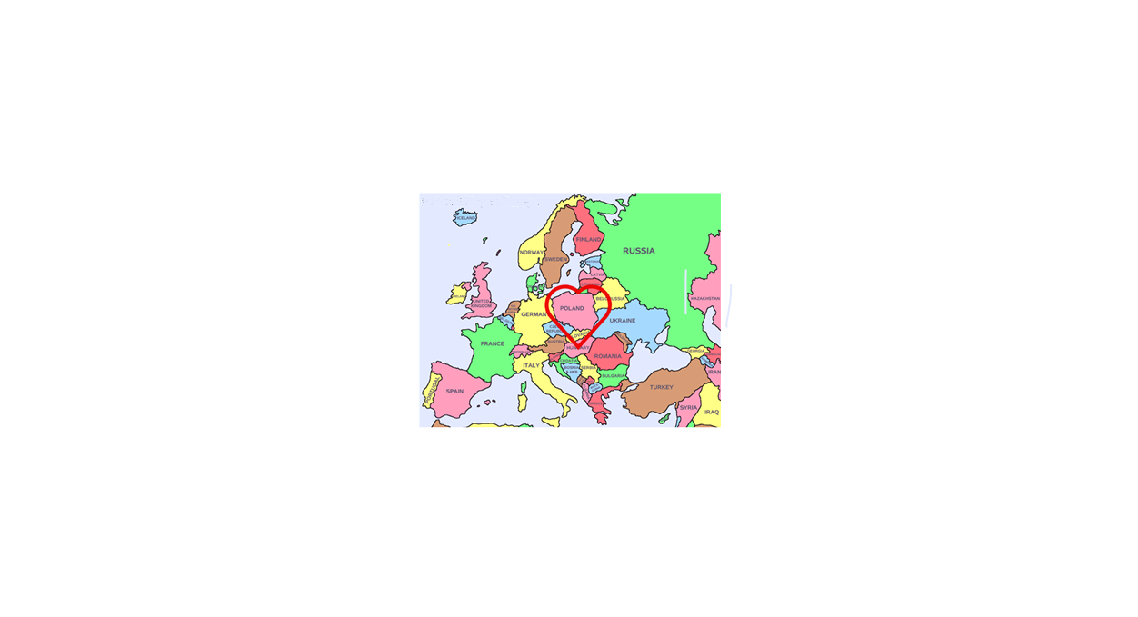**PACT’23 –** Meeting #19

Thursday – June 22, 2023

3 PM – 4:27 PM EST

Participants:

Andrzej P, Gienek, Halina, Edmund, Jacek, Jola Jerzy B., Krzysiek, Ryszard, Szymon, Zbyszek

**POLAND**

**THE HEART OF EUROPE**

Map from the Brochure for Congressmen

**What has happened since our last meeting?**

* Jola participated last weekend in a 3-day event commemorating the completion of the project of erecting tombstones for Blue Army soldiers at Holy Sepulchre Cemetery in Southfield in the Detroit area. 200 people attended including Consuls from Canada and Chicago. According to Jola, it was the best organized event, she has ever attended. The organizer was the Polish American Institute of Culture & Research which is one of the Orchard Lake School institutions.<https://www.detroitcatholic.com/news/new-tombstones-ensure-bravery-of-polish-blue-army-volunteers-is-never-forgotten>
* Krzysiek and Zbyszek continue to work on a trifold brochure for legislators.
* Gienek informed us about co-sponsorship of H.R.82: 284 congressmen have already signed up. We should continue to contact those who have not.

**We talked about:**

* A surprising decision of President of Coalition of Polish Americans (CPA) not to propose a resolution commemorating the 80th Anniversary of the Wołyń genocide. He also announced that he was not going to the congress of the “Wspólnota Polska” to protest against ignoring the CPA by not inviting its members to panel discussions.
* An unusual project by Henrietta Nowakowski (aged 94) to erect new tombstones for Blue Army soldiers with the help of the Institute of National Remembrance.
* A brochure informing congressmen about Poland.
* PACT’23 Report #18 was NOT read (we had to end the meeting earlier).

**It was decided**:

* Zbyszek will send the participants of the meeting a fragment of the brochure about WWII to get their suggestions on what should be included there. For now, the following parts are ready for consultations with a wider audience:
* Historical milestones of the last 1,000 years
* The contributions of Polish Americans
* A nation of unparalleled Liberty and Tolerance

**Recommended:** fascinating story of Józef Haller: <https://www.historynet.com/polands-men-in-blue-and-their-struggle-for-independence/>

**Next meeting:** PACT’23 > Thursday, June 29, 2023 at 3 PM EST via Skype

AGENDA: current events + this and previous report will be read and commented on

zk 6/26/23

 **PACT’23 –** Meeting #20

Thursday – June 29, 2023

3 PM – 4:52 PM EST

Participants:

Andrzej P, Gienek, Edmund, Jacek, Ryszard, Zbyszek

**What has happened since our last meeting?**

* Ryszard told us about the event commemorating Mieczysław Madejski, captain of the Warsaw Uprising in the famous Zośka group, one of the organizers of PAC- Long Island and its Honorary Member. Halina worked on this project for over a month.
* Today is the first day of the 6th Congress of the Polish Diaspora and Poles from Abroad (it will last until July 2). The World Polonia Council and the "Wspólnota Polska" Association organize this event every 5 years.
* Zbyszek continues to work on a brochure for legislators.
* Gienek: elections were held in their PAC-Missouri Division. There were no changes in positions. Gienek does not perform any official functions, he is an Honorary Officer.
* Gienek informed us about the co-sponsorship of H.R.82: 286 congressmen have already signed up. Let's now focus on the Chairman and members of the Means & Ways Committee to avoid the situation we faced in the last session of Congress.

**We talked about:**

* The first day of the 6th Congress of the Polish Diaspora and Poles from Abroad. It is attended by representatives from 43 countries. Edmund reported from the bus returning to Warsaw from the “Mazowsze” concert about: the morning mass, participation in the Sejm session, a meeting of CPA members with Minister Antoni Macierewicz. According to the Minister, Ukrainians understand that the issue of Wołyń will not disappear. Organizers of the Congress wanted to see the draft Resolution on the genocide in Wołyń prepared by members of CPA Krzysiek and Staszek. Edmund told us about his ignored proposal to hold a press conference with the CPA.
* Wołyń Resolution. Jacek did not go to the concert but made copies of the Resolution. He has already made 50 and is working on another 173. He intends to distribute them to all participants of the Congress of the Polish Diaspora.
* PACT’23 Report #18 and #19 were read and commented on.
* Brochure for legislators. We spent some time discussing changes and what to add.
* Smoke from burning Canadian forests and hot weather.
* Special Holly Mass celebrated by Archbishop Stanisław Gądecki in the Warsaw Cathedral in the intention of reconciliation for the genocide in Wołyń on June 7.

**What was decided:**

* Zbyszek will resend letter that was sent to Rep. Jason Smith by PAC-LI.
* Zbyszek will read the info on PAC-Missouri website about the contribution of Poles.
* Zbyszek will continue to try to find contacts with the Greeks re war reparations.
* Zbyszek will resend the info concerning reparations Halina received.
* Zbyszek will send a link about the Texas Bishop that has problems with Vatican.

**Recommended:** Wołyń [**https://www.pap.pl/aktualnosci/news%2C1584866%2Cabp-stanislaw-gadecki-pojednania-polsko-ukrainskiego-nie-mozna**](https://www.pap.pl/aktualnosci/news%2C1584866%2Cabp-stanislaw-gadecki-pojednania-polsko-ukrainskiego-nie-mozna) **and** about PiS <https://www.facebook.com/miroslaw.kostro.9/posts/pfbid0fx5dvZYshvdFMm3oTvT76kgay4sRwtEsrCAcZwWTehmCoSNnWJb8AspMdA8kxpRil>

**Next meeting**: IOM’23 > Wednesday, July 5, 2023 at 3 PM EST via Skype

AGENDA: current events + this report will be read and commented on

zk 7/04/23

**IOM’23 –** Meeting #7 Wednesday – July 5, 2023 3PM – 5:39 PM EST

Participants:

Andrzej P, Gienek, Halina, Edmund, Jacek, Jola, Jurek B., Ryszard, Szymon, Zbyszek

This meeting was held at 3 PM, not at 8 PM as traditionally, to hear fresh impressions of participants, who were still in Poland, about the 6th World Polonia Congress.

**What has happened since our last meeting?**

* Szymon told us that a few members of his 37-member group (their goal is to empower citizens) are working on a letter to Polish legislators about their proposal to create a civil state as it was 500 years ago and is currently in Switzerland. They will collect replies from deputies. He recommended that we read the Swiss Constitution (art. 137-42).
* Zbyszek: the brochure for legislators was refined by his son’s girlfriend.
* Gienek: at PAC-Missouri web we can read about the events of June 56 in Poland.
* No-one has heard from PASI about their recent efforts to repeal WEP for some time.

**We talked about:**

VI Congress of the Polish Diaspora and Poles from Abroad (June.29- July 2).

We listened and asked questions to the participants of the Congress: Edmund, Halina, Jacek. 350 members of organizations from 43 countries stayed at the Novotel, the former Forum hotel in the center of Warsaw. It was noisy at night due to police sirens and a local disco. This made it difficult to rest after exhausting days. At meals and during bus journeys, there was time for conversations. Edmund: one of the important conclusions was the idea of organizing a Youth Festival (for those under 28) in the future. Halina presented “Flavor of Poland” at the Cultural Forum. 20 organizations were awarded, including the Coalition of Polish Americans (the award was collected by Dr. Śliwowski). Polonia is the best organized in Lithuania. PAC was represented by only 5 people (because it was not advertised by the leadership): Bożena and Andrew Kaminski, Grażyna Michalska, Frank Spula, Małgorzata Schulz. 9 people from the CPA came (15 were planned). Halina was the first to stand up and encouraged others to support the Wołyń Resolution prepared by Krzysiek and Dr. Stanisław. Sometimes there was too much coffee or nothing to drink during panels. There was no discussion about how to fight for Poland's good name. Hotels and meals were paid by government. According to Edmund, it was possible to apply for a refund for the plane ticket. Edmund spoke with the Chairman of Polonia Council, Tadeusz Pilat from Sweden, who seems to be open to suggestions such as changing the By-laws which says that only the PAC can represent the US.

Conclusions/suggestions for the organizers:

1. The date should be announced at least 6 months in advance.

2. Consulates should notify organizations about the coming Congress.

3. The Hotel should be less noisy and without a disco.

4. There should be a special time to meet people from other organizations.

5. Water bottles should always be available.

**What was decided:**

* Zbyszek will find a copy of the Wołyń Resolution that was approved at the Polonia Congress and send it to the PACT group.
* Jola will send the text of Honorary Consul Richard Walawender' speech.
* Gienek: his PAC division will prepare info about the Wołyń genocide.
* Zbyszek will ask Dianne what is going on with the H.R.82 campaign.

**Next meeting**: PACT’23 > Thursday, July 27, 2023 at 3 PM EST via Skype

AGENDA: current events + this report will be read and commented on

zk 7/7/23

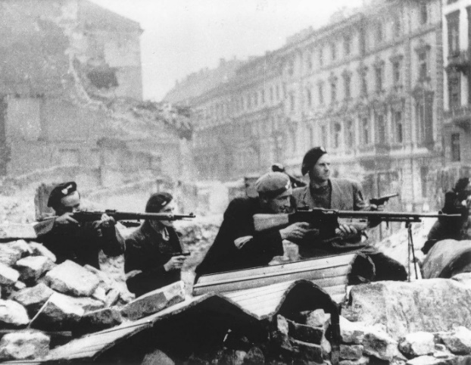 **PACT’23 –** Meeting #21

Thursday – July 27, 2023

3 PM – 4:55 PM EST

Participants:

Andrzej, Gienek, Halina, Jacek, Ryszard, Zbyszek

August 1944

We will not forget about the insurgents

After we were done, Krysia connected and told Halina and me about her observations.

**What has happened since our last meeting?**

* A week ago, the Board of the Coalition of Polish Americans (CPA) held its monthly meeting, the first after the end of the VI Polonia Congress. There was no mention of the Wołyń Resolution and there was no regret that the Resolution was presented by a Polish Americans group and not by the CPA. Not a word about the CPA wasting an opportunity to show the international Polonia that it exists.
* Dr. Łucja Cannon wrote an article in the July 26 Washington Examiner titled "The NATO Summit Revealed the US-German Partnership of Weakness". Her observation that the US is cooperating with Germany by not proposing dates for Ukraine's accession to NATO, signals that efforts to gain US support in the matter of compensation for Poland may encounter great difficulties.
* Last Friday several Polonia activists, including Andrzej Burghardt and John Czop met with a Jersey Journal journalist and presented a Polonia's point of improvement around the Katyń Monument. Specifically, they would like the wall from the Montgomery Street to be removed.
* Gienek reported that no new supporter of H.R.82 appeared since our last meeting two weeks ago. Only 2 more co-sponsors are needed to trigger the automatic placement of H.R.82 on the Congress Calendar. Rep. Jason Smith, Chairman of the Ways and Means Committee does not respond to our letters. This does not bode well.
* Jacek met with various politicians in Poland. Sebastian Kaleta, an official of the Ministry of Justice is planning a visit to the US in the near future.

**We talked about:**

* The changes in the Polish Geological and Mining Law voted by the Sejm on June 16, 2023 (Sejm document No. 3238). Andrzej tried to explore the topic of this amendment and shared his observations. The basic problem is the number of pages: 890. The CPA's claim that the PASI letter attacks the PiS government is not correct. It seems, however, that the amendment is a threat to private property. All PiS legislatives voted for, all PO against. Gienek: There have been studies of shale deposits and probably this act is to help in granting licenses for drilling.

**What was decided:**

* Those who can should travel to Washington DC to participate in a rally on Sept. 13 to meet the media and congressmen regarding the repeal of WEP.

A book I read and **recommend** to anyone interested in laws that govern our world:

“The Grand Design” by Stephen Hawking

**Next meeting**: IOM’23 > Wednesday, August 2, 2023 at 8 PM EST via Skype

AGENDA: current events + this report will be read and commented on

zk 7/31/23

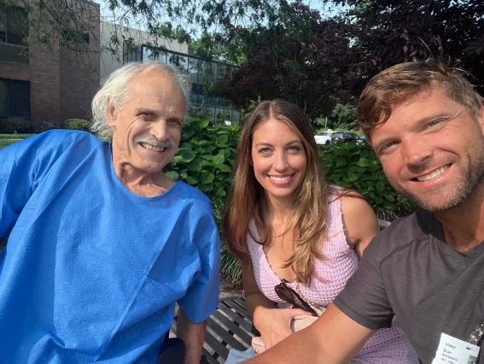**IOM’23 –** Meeting #8

Wednesday – August 2, 2023

8 PM – 10:07 PM EST

Participants:

Andrzej, Gienek, Jim, Krysia, Ryszard, Szymon, Tomek, Zbyszek

At Stern Rehab 2 weeks after surgery

**What has happened since our last meeting?**

* Online arguments about the Katyń Memorial site. Instead of uniting to remove the wall from Mongomery Street Ms. Piórkowska and her supporters attacked Mr. Mazur with nasty emails and minimized his and Ms. Huang's efforts. Arguing is distasteful and completely unnecessary since now everyone agrees that the wall in front of the Monument should be removed. Andrzej: excessive ego may be the only explanation.
* According to Dr. Geen Sokolowski, Rep. Chris Smith, the New Jersey Republican has signaled a willingness to co-sponsor the Reparations Resolution.

**We talked about:**

* Jim told us about a 5-week exch. program between students from Poland and Texas.
* Errors in compensation info. Gienek pointed out to the wrong date of the report was prepared and two different estimations of reparations.
* Civil State. Szymon told us about his group mission which consistently and patiently works to educate Polish society about the civil state and its advantages. There was a discussion. This is an important undertaking and it is great that there are people who have dedicated themselves to this cause.
* Upcoming elections in Poland. Szymon is in favor of informing Polonia who to vote for. Andrzej: our Polonia knows how to vote; the problem is with European Polonia.
* According to Szymon, 20% of Poland is under the jurisdiction of the EU.
* Contact with Rep. Marcy Kaptur. Tomek will have the opportunity to meet Ms. Kaptur during the Ukrainian Parade which will take place on August 24. This is the best way to talk to her, because her stuffers ignore us.
* Free KUL educational program for 2023/24. Gienek read the titles of all 18 lectures.
* Disruption of communication on the CPA Forum. Andrzej informed us that not all recipients get messages, they are apparently blocked by AI.

**What was decided:**

* Dr. Jim will contact Zach, assistant to Rep. McCaul, chairman of the Foreign Relation Committee, and ask which version of the Resolution would be acceptable to his colleagues on the Committee. This is critical info without which there is no chance of introducing the Compensation Resolution.
* Zbyszek will share with Halina who is in contact with Polish officials, regarding errors found by Gienek in the Polish government official info on reparations.
* To look at how Armenians and other groups raise funds for their activities.

**Next meeting**: PACT’23 > Thursday, August 10, 2023 at 3 PM EST via Skype

AGENDA: current events + previous and this report will be read and commented on

zk 8/3/23

**PACT’23 –** Meeting #22

Thursday – August 10, 2023

3:10 PM – 5:53 PM EST

Participants:

Andrzej, Dr. Gene, Gienek, Jacek, Krzysiek. Mariusz, Ryszard, Tomek, Szymon, Zbyszek

I would like to thank Richard for waking me up and I apologize to all participants for keeping you waiting for me to start today’s meeting. This meeting was not recorded.

**What has happened since our last meeting?**

* Zbyszek spoke to Dr. Gene about where we are on the Compensation Resolution and what is needed to start moving this project forward.
* Zbyszek sent an email to Zach today reminding him that we are awaiting his and his colleagues’ views on draft resolutions. To show that this issue is important, a copy of this email was sent to several presidents of Polonia organizations.
* Gienek: only one more co-sponsor is needed for H.R.82 to be placed on the list of the US Congressional Consensus Calendar.
* PASI and the Task Force organized an appeal to preassure AARP to support the removal of WEP. Dr. Gene: WEP and GPO. affect 2.5 million Americans.
* Andrzej: Ordo Iuris sent a note against the new Geological Law.

**We talked about:**

* What needs to be done to bring the Compensation Resolution closer to be introduced in the US Congress. We need opinions, comments and blessings from the staff of Reps in the Committee on Foreign Affairs. We must continue to put pressure on Zach, with whom Dr. Jim has a close relation. The staffers of Marcy Kaptur had already been working with Dr. Gene in January and had only to find a Republican co-sponsor. Marcy cooperates with the Polish left-wing opposition and this may be the only reason why she stopped responding. Most likely PiS opponents contacted her.

**What was decided:**

* Zbyszek will contact Dr. Mark Pienkos and talk to him about persuading the President of PAC, Frank Spula to join our efforts to introduce in the Congress a Resolution on compensations for WWII.
* Szymon: when referring to the monument in Jersey City, we should use the name: "Katyn 1940 - Genocide Memorial". It is important to use this full name. Eventually it will be intercepted by Google and other search engines, spreading the word about this crime.
* A team: consisting of Andrzej, Krzysiek, Ryszard and Zbyszek will work on a text to be sent to PAC\_ND Forum on the compensation for WWII. The goal is to motivate the PAC leadership to engage in this project, comparable in scale to the fight for Poland's admission to NATO.
* Ryszard will send a private email to Mr. Spula and Mrs. Kaminska inquiring about the resolutions of the VI Polonia Congress and how PAC intends to get involved in their implementation. He will also ask when and where elections in the PAC are planned.
* Andrzej plans to go next week to " Katyń 1940 - Genocide Memorial" on Thursday, Aug.17 where EPASID will celebrate the completion of work on improving the monument's surroundings. At the same time a demonstration is scheduled to take place demanding the removal of the wall from the Montgomery Street.

**Next meeting**: PACT’23 > Thursday, August 17, 2023 at 3 PM EST via Skype

AGENDA: current events + this report will be read and commented on

zk 8/12/23

**PACT’23 –** Meeting #23 Thursday – August 17, 2023

3:00 PM – 5:23 PM EST

Participants: Andrzej, Dr. Gene, Gienek, Halina, Jacek, Janusz, Jola, Krystyna, Krzysiek. Ryszard, Szymon, Zbyszek

Thank you Krzysiek for participating, even though you had hip surgery just two days ago.

**What has happened since our last meeting?**

* Zach sent a reply to Zbyszek that he was still waiting for responses from staffers.
* Andrzej Burghardt, Jeanne Daly, Irena Guilion, John Czop attended the regular meeting of the Jersey City Council. Each had 3 minutes to express their appeal for the removal of the wall in front of the monument. The best text was prepared by Dr. Gene: councilors were asked if they would allow to cover the monument commemorating the battle of Iwo Jima with a wall. PASI prepared two professional banners and commissioned an aerial picture of the monument to show that 40% of the public space had been given away.
* Ryszard sent email to Mr. Spula and Mrs. Kaminska concerning the VI Polonia Convention. Despite sending it twice he got no reply.
* Halina asked Simon to correct the claim link and resend his email to Dr. Gene.
* Zbyszek contacted Dr. Mark Pienkos and talk to him about persuading the President of PAC, Frank Spula to join our efforts to introduce a Compensation Resolution in the Congress. He did the same with John Czop. Zbyszek also sent emails.
* John Czop sent to Andrzej and Zbyszek his proposed additions to PAC By-Laws:

1. As the top governing body of the Polish American Congress, the Council of

ND should approve Statements prepared by the PAC Executive Committee.

2. The POLISH AMERICAN CONGRESS CHARITABLE FOUNDATION must either agree to contribute several million dollars to the Polish American Congress, or to delete from its name the words: Polish American Congress.

**We talked about:**

* Jola told us about her vacation with her grandchildren. They were also in Białowieża, Polish American scout camp, 30 miles from Detroit on north side of the Huron.
* Which congressmen should we approach, who could introduce the Resolution. Freshman and member of the subcommittee on Europe, Rep. Mike Lawler (R) from NY. district 17 was suggested by Dr. Gene.
* Who could be nominated to the PAC Executive Committee

**What was decided:**

* Andrzej agreed to give an interview to Agnieszka Wrocławska from the Chicago radio, as suggested by Krzysiek, on the subject of "Katyn 1940 - Genocide Memorial" in NJ.
* Andrzej convinced us to work, as we decided a week ago, on the text to be sent to PAC\_ND Forum re the compensation for WWII and not to wait for the result of Dr. Mark’s conversation with Mr. Spula. Andrzej, Krzysiek, Ryszard and Zbyszek will try to motivate the PAC leadership to get involved in this project.
* Ryszard will send a follow up message to Małgosia Schulz regarding the lack of response to his two emails sent to Mr. Spula re the results of the VI Polonia Congress.
* Krzysiek will try to contact Rep. Raja Krishnamoorthi (D) and ask if he would be willing to submit a Resolution on Compensation for Poland for WWII.
* Andrzej and Ryszard will send their amendments to the PAC By-Laws.

**Next meeting**: PACT’23 > Thursday, August 24, 2023 at 3 PM EST via Skype

AGENDA: current events + this report will be read and commented on

zk 8/18/23

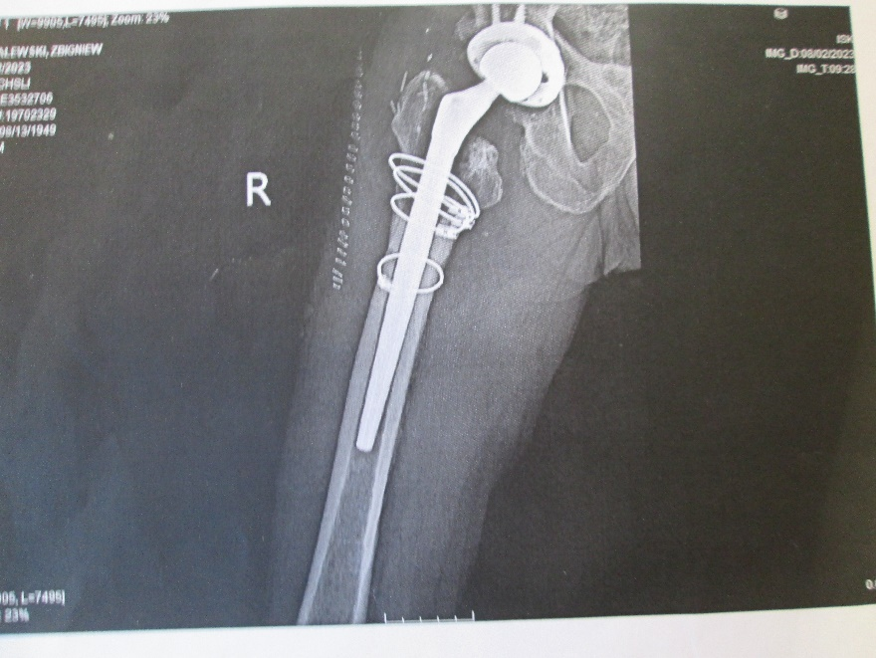 **PACT’23 –** Meeting #24

Thursday – August 24, 2023

3:00 PM – 5:56 PM EST

Participants:

Andrzej, Andrzej P., Dr. Gene, Gienek, Jacek, Jola, Krzysiek. Renata W., Ryszard, Szymon, Zbyszek

extreme hip revision surgery

where 1/3 of the femur had to be removed

**What has happened since our last meeting?**

* Ryszard sent his proposal to Andrew Kaminski, Chaiman of the PAC By-Laws Committee: Article IV Officers Powers and Duties, Section 3, Powers and Duties of Secretary Paragraph a. Please add the following sentence: The minutes of the Executive Committee meeting shall be prepared and distributed to PAC National Directors and Division Presidents no later than thirty days after the meeting.
* PAC President, Frank Spula called Ryszard back but he was not at home at the time.
* Ryszard did not receive confirmation from Małgosia Schulz that she had received his email previously sent to Mr. Spula. There is also no confirmation from Mr. Kaminski.

**We talked about:**

* Szymon spoke about the need to amend the Polish Constitution to enable citizens to introduce a referendum if 500.000 people sign this request.
* A letter to be left in at congressmen's offices re WWII compensations. What to add to make it more convincing.
* Summary of Dr. Gene’s info on Polish losses as a result of WWII. Adding a percentage to population and land losses would be more descriptive.
* Rally in support of WEP and GPO repeal at the foot of the Capitol on September 13 at 3 PM. Dr. Gene gave us details of the plan of the day. He told us that the car, amplifiers and all equipment must undergo rigorous inspections before being allowed to be brought near the Capitol. The event will be streamed live on Facebook.
* Excerpts from a letter sent to Mr. Spula by Minister Arkadiusz Mularczyk asking for support in seeking compensation for WWII.
* Interview on the TV Trwam. Gienek was surprised to hear false information about WEP.

**What was decided:**

* Andrzej will send his proposal to amend the PAC By-laws to Andrew Kaminski.
* Andrzej, Krzysiek and Zbyszek will continue to refine the letter to be left at congressmen's offices re WWII compensations.
* Dr Gene will make minor additions in his summary of Poland’s losses in WWII..

**Next meeting**: PACT’23 > Thursday, August 31, 2023 at 3 PM EST via Skype

AGENDA: current events + this report will be read and commented on

zk 8/25/23

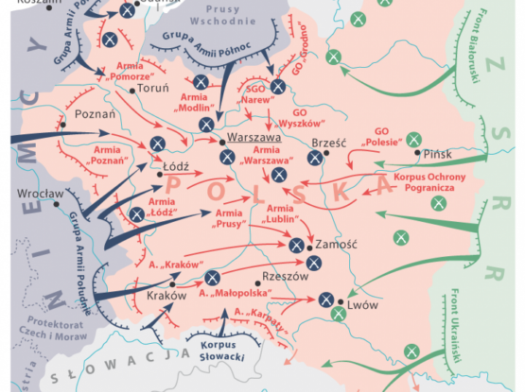**PACT’23 –** Meeting #25

Thursday – August 31, 2023

3:00 PM – 5:51 PM EST

Participants:

Andrzej, Dr. Andrzej., Edmund, Dr. Gene, Gienek, Halina, Jacek, John, Jurek B., Krzysiek. Ryszard, Szymon, Zbyszek

September 1939

- we will not forget

**What has happened since our last meeting?**

* Dr. Gene told us about Rep. Chris Smith's strong support for compensations to Poland. Rep. Marcy Kaptur was notified about that. Link to press release of Rep. Smith:

<https://chrissmith.house.gov/news/documentsingle.aspx?DocumentID=411619>

* Gienek noticed that the text under the compensation link was changed.
* Dr Gene plans to attend an event at the Polish Ambassy commemorating Ulma family. Perhaps he will have the opportunity to talk about the compensation project.
* Minister Arkadiusz Mularczyk will try to meet with Rep. Kaptur sometime in September.

**We talked about:**

* Szymon spoke again about the need to amend the Polish Constitution and his involvement in this project. His group has contacts with Rafał Piech who has similar ideas. Szymon emphasized that his group has no ambition to be a political party, his organization is a social movement.
* Jurek B. informed us about the political movement “Poland is One”. It is a civic initiative that was initiated by the Mayer of Siemianowice Śląskie, Rafał Piech in September 2021. It focuses on protecting the freedom of every citizen and their constitutional right to decide about themselves and their health.
* 3 new columns added by Zbyszek and improved by Andrzej and Krzysiek was read. A new version of the letter for congressmen was also read and commented on.
* The report of the last meeting was read and commented on.

**What was decided:**

* Halina will ask Simon what word and when we should use: reparation or compensation.
* Anyone who can should come to DC for the WEP/GPO repeal rally next week on Wednesday, September 13. The event will take place at the Capitol in Area 11.
* Ryszard will ask a neighbor who worked as a professional editor to look at a trifold brochure for congressmen.
* We need to shorten the title of the Hybrid Resolution which includes paragraphs from: H.Res.664 and Dr Gene’s Compensation Resolution.
* We need to review the cover letter that was supposed to be left with congressmen after visits to their local offices.
* John will try to find out why Mr. Spula is not involved in the compensation project.

**Recommended** by John Czop: “The Enigma war” by Józef Garliński.

**Next meeting**: IOM’23 > Wednesday, September 6, 2023 at 8 PM EST via Skype

AGENDA: current events + this report will be read and commented on

zk 9/1/23

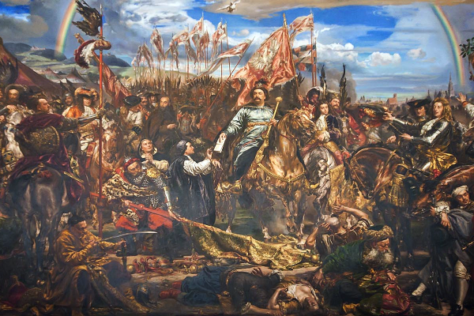**IOM’23 –** Meeting #9

Wednesday – September 6, 2023

8 PM – 9:39 PM EST

Participants:

Andrzej, Dr. Andrzej, Gienek, Jacek, Jola, Jurek B., Krzysiek, Szymon, Zbyszek

Sept. 12, 1683

Jan III Sobieski

odsiecz wiedeńska

Obraz Jana Matejki

**What has happened since our last meeting?**

* Halina once again received the message confirming that we should use the word compensation not reparation.
* Zbyszek improved the proposed Hybrid Resolution.
* The Coalition of Polish Americans announced that it will organize a Convention and elections in Orchard Lakes Schools on Nov. 4-5.
* Andrzej gave an interview to Agnieszka from Chicago radio about the Katyń Monument.

**We talked about:**

* According to Jurek from Florida, of all the occupied countries, only Poland did not collaborate with Germany. If it is true, we will have to correct the info in the brochure where we also have Czech Republic and Greece (according to Dr. Ewa Kurek).
* Zbyszek explained that the WiR organization to which Szymon belongs, has no political aspirations. The political movement “Poland is one”, headed by Rafał Piech, wants to become a political party and is collecting signatures for this purpose.
* Jola recommended reading a recent article by Waldemar Biniecki in which he analyzes Polonia and the Polish raison d'état. Then a discussion ensued.
* Events of other ethnic groups in front of the Katyń Monument. Apparently, some on the City Council argued that the wall would help separate the events from the monument.

An emotional discussion followed whether such events should be allowed.

* Andrzej from California stopped receiving info about our weekly meetings. Andrzej from New Jersey has a suggestion on how to check whether e-mails are received.

**What was decided:**

* Everyone who can should take part in the events at the Katyń Memorial:

on Sunday, Sept. 10 at 3 PM is organized by Committee of the Katyn Crime 1940 (chairman Krzysztof Nowak), the Association of Polish Army Veterans and the Polish American Congress, and

a week later, on Sept. 17, by the Committee for the Protection of the Katyn Monument and Historical Objects chaired by Bogna Huang.

* It would be interesting, as Andrzej mentioned, to find out with which countries Germany signed a peace treaty.
* Gienek asked to check whether there are any significant differences between the text sent by Jan Karski Institute and later replaced under the same link by the Ministry of Foreign Affairs, regarding compensation for WWII.

**Next meeting**: PACT’23 > Thursday, Sept. 14, 2023 at 3 PM EST via Skype

AGENDA: current events + previous and this report will be read and commented on

zk 9/9/23