
PACT’26 – Meeting #1

Thursday, January 15, 2026
8:00 – 10:10 PM

Participants:
Andrzej (NJ), Andrzej (OR), Gienek (MO),
Halina (LI), Jola (MI), Jurek (FL), Krzysiek (IL),
Mirek (IL), Paulina (CA), Marek (MO), Piotr (MO),
Ryszard (LI-NY), Tomek (OH), Zbyszek (LI)

This meeting did not take place on Jan. 8, as planned because the PAC monthly presidents meeting
was held on that date.

What has happened since our last meeting?

- Jurek informed us that so far 10 cabins have been booked for the integration cruise in March.
- No one knows a lawyer who would have the knowledge about academic foundations that Dr Krystyna asked us for. It was advised to search for these specialties on the internet.
- Tomek (OH) did not receive a response to his letter to Senator Moreno.
- Mirek (IL) sent a legislative status, confirming Tomek's (DC) earlier opinion on The Exclusive Citizenship Act, introduced by Senator Bernie Moreno from Ohio.
- Ela (NM) sent info and her opinion on the 2013 Tax agreement between Poland and the USA.
- At the meeting, organized a week ago by PAC VPs for American and Polish Affairs, Andrzej’s (NJ) proposal re Polish parishes was discussed. Mr. Kolodziej intends to appoint a team to deal with this matter. Ryszard (LI-NY) would like this team to also monitor the condition of Polish Saturday schools, which in most cases operate thanks to churches and with their support. It is worth mentioning that unlike the previous PAC President who did not attend Tim/Bozena's meetings, our new President was present at this first meeting between the newly elected EC and the Presidents of PAC organizations.
- Jola received a recording of the meeting mentioned above.
- No one sent comments or suggestions for the column that Zbyszek (IL-NY) prepared on what connects Poland and Italy, for the Italian version of the Brochure about Poland.
- Roman Korzan (DC) sent the unanimously adopted PAC resolution on WWII Compensation to the ND Forum, apparently expecting further action.
- John (NJ) resubmitted his proposal to organize a campaign on Capitol Hill and contact law makers (as Prof. Bajdek did by issuing Legislative Alerts)) to help Poland obtain lower prices for American weapons.

What we talked about:

- Report from the last meeting was read and commented on.
- Receiving a pension from work in Poland – confirmation of termination of employment is required. Piotr (MO) - we should try to change this law.
- Saving Polish Churches – Andrzej's (NJ) initiative. Tomek (OH) recalled how parishioners successfully saved St. Casimir church in Cleaveland. Gene (OH) recalled a similar successful joint effort to save a church in Saint Louis. Zbyszek (LI-NY): much depends on the determination and ingenuity of the parishioners.
- Helping Poland to modernize her armed forces - John's (NJ) initiative.

What was decided:

- It was confirmed that PACT will not become an organization. PACT participants want it to remain an informal, open forum.
- Jola will resend the flyer about the integration cruise on NDs Forum.
- Zbyszek will ask his congressman why the 2013 Tax Treaty has not been ratified by the US.
- Teams will be established to deal with the double taxation treaty and the requirement to cease employment in order to receive a pension in Poland.

Next meeting: PACT’25 > Thursday, January 22, 2025, at 8 PM ET
AGENDA: this report will be read and commented on + current events. zk, 1/16/26

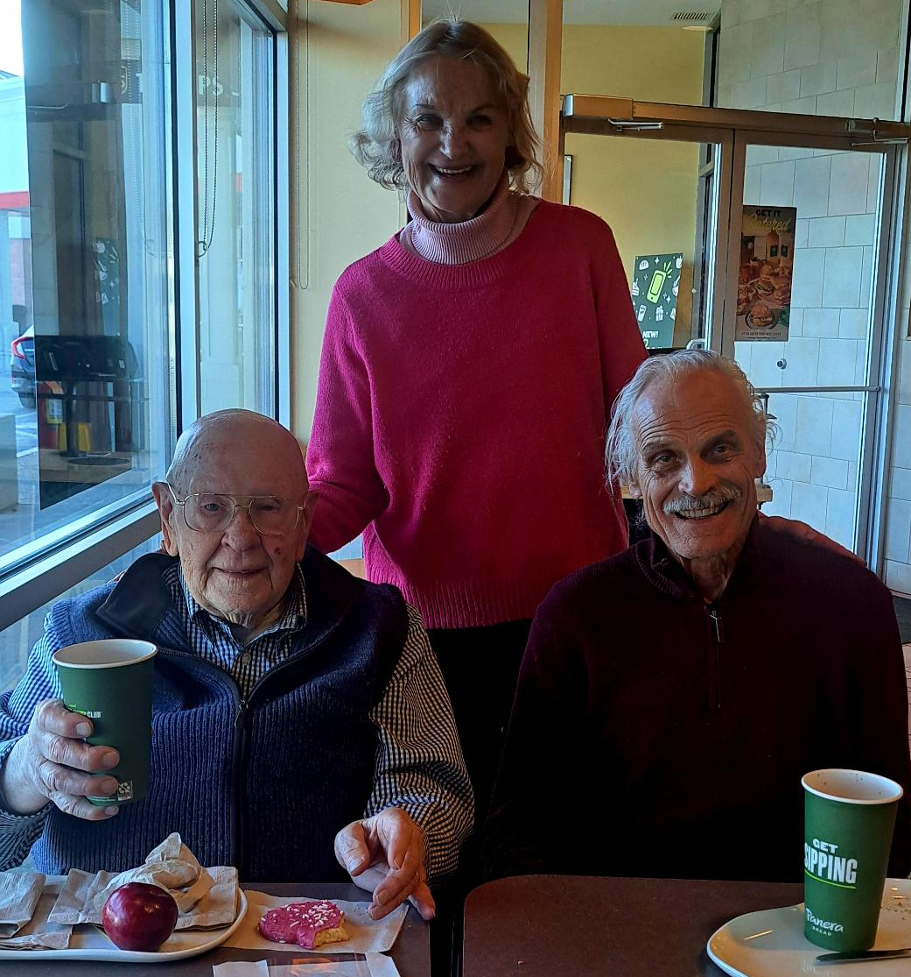
PACT’26 – Meeting #2
Thursday, January 22, 2026
8:00 – 11:00 PM

Participants: Andrzej (NJ), Gienek (MO),
Halina (LI-NY), Heniek (Ctr-NY), Irena (WI),
Jola (MI), Paulina (CA), Piotr (MO),
Ryszard (LI-NY), Tomek (OH), Tomek (AZ), Wojtek (south-CA), Zbyszek (LI-NY)

Richard Brzozowski, President of PAC-Long Island, served in the Marine Corps
during the Korean war. For decades, he has been active in many organizations Two days ago, we celebrated the 95th Birthday of this exceptional man and our treasure.

What has happened since our last meeting?

- Zbyszek (LI-NY) asked his congressman to investigate why the 2013 Tax Treaty was not
ratified by the US Senate. Rep. Suozzi’s assistant responded immediately and will try to find out.
- Last Saturday, Gene (DL) called a meeting re the 2013 treaty. Ela, Gienek and ZK took part in it.
- Zbyszek received a warning that a well-known Polonia institution, the Polish Cultural Institute in New York was operating as another Jewish center.
- Ela (NM) sent a detailed summary of the 2013 Tax Treaty.
- Steve Floor is in the hospital again. We wish him a speedy recovery.
- The updated Statute was sent to Mr. Grzymala for verification of the correctness of the changes.

What we talked about:

- Report from the last meeting was read and commented on.
- EC meetings. It is good that they meet weekly (the previous board met monthly) but their agenda remains secret, and the reports are not available. The question was, why is this happening?
- Double taxation. Gienek (MO): Poles returning to Poland must pay two taxes. Discrimination arguments can be used to persuade the Senate to ratify the Treaty, as other countries are exempt.
- Polish parishes. Andrzej (NJ) volunteered to join the team that Tomek (DC) promised to organize. . Suggestions were made as to what this team could do, despite individual situations.
- John’s initiative to obtain a special price for Poland for the purchase of American weapons. Zbyszek argued that it was worth taking a closer look at it and seeing what can be done.
- Celebration of the 250th anniversary of the US. Zbyszek proposed preparing a brochure about the contribution of Polish Americans. Jola (MI) and Tomek (OH) would prefer online publication, hoping to reach a wider audience.
- Brochure about Poland – Italian version, what connects these two nations. Tomek (OH) suggested using AI to check whether the proposed content would be interesting/attractive to the recipients. Wojtek (south-CA shared the contact info of a Polish Italian activist who could also help.
- Requirement to terminate employment to receive a pension in Poland. Piotr (MO): Apparently a bill abolishing this provision has been submitted to the Polish parliament.
- How to reach the young generation. Tomek (OH): Beer and pierogi are no longer an attraction.

What was decided:

- Irena (WI) will ask Hubert to tell us about what EC members discuss at their meetings.
- Zbyszek (LI-NY) will send info prepared by Ela (NM) re the 2013 Tax Treaty to the PACT group.
- Tomek (OH) plans to meet with the local bishop and talk about threats re Polish parishes
- The EC will be asked to engage in work on the ratification of the 2013 Treaty.
- Jola (MI) will ask the EC whether intends to respond to the situation in Poland.
- Divisions will distribute leaflets in Polish and English about the cruise prepared by Jola (MI).
- In addition to reading this report, we will take part in a lesson on AI led by Tomek (OH).
- We will ask the VP for Culture to take an interest in the activities of the Polish Cultural Institute.

Next meeting: PACT’25 > Thursday, January 30, 2026, at 8 PM ET
AGENDA: this report will be read and commented on + current events. zk, 1/23/26

Attached below is the latest correspondence between Dr. Gene and Elizabeth (our expert)
which should assist us in our efforts to ratify the 2013 Treaty.
Hi Elżbieta,
Thank you very much for your detailed analysis.
I’d like to offer a few thoughts for consideration about both treaties and then address why the 2013 Treaty was blocked.
In the 1974 Treaty, Article 20, Relief from Double Taxation, paragraph 1 states “…Poland shall allow to a resident of Poland as a credit against the Polish tax the appropriate amount of taxes paid to the United States.”
I read this to mean that the burden of tax relief rests with the resident of Poland. To obtain relief for taxes paid to the U.S., he/she must include those taxes as a credit against the Polish tax when filing his/her taxes with Poland.
Correct, but relief from double taxation applies on both sides of the Atlantic and rests with taxpayers.
The U.S. taxes its citizens and residents on worldwide income, but it allows a Foreign Tax Credit (FTC) for income taxes paid to Poland. This prevents double taxation up to the U.S. tax limit.
Poland taxes its residents on worldwide income as well but reduces Polish tax by the amount of U.S. tax paid on U.S.-source income. Poland also uses the credit method, proportionally reducing Polish tax by U.S. tax already paid.
===
In the 2013 Treaty, Article 18, Pensions, Social Security, Annuities, Alimony, and Child Support, paragraph 1 states “Pensions, annuities and other similar payments made to and beneficially owned by a resident of a Contracting State shall be taxable only in that State.”
I read this to mean that a private pension earned by a Polish individual while in the U.S. and who resides in Poland shall only be taxed by the U.S.
Read also next paragraph 2 of Article 18.
2. Notwithstanding the provisions of paragraph l, pensions and other similar payments arising in a Contracting State (say, US) that, when received, would be exempt from taxation in that State (US) if the beneficial owner were a resident thereof (US) shall be exempt from taxation in the Contracting State (Poland) of which the beneficial owner is a resident.
My comment: US private pensions, withdrawals from IRA, 401(k) etc. are not exempt from taxation in Poland, therefore, for US tax residents (citizens, Green Card holders) they are taxable both in the US and in Poland. Double tax avoidance applies.
===
Paragraph 3 of Article 18 states “…payments made by a Contracting State under the provisions of the social security or similar legislation of that State to a resident of the other Contracting State or to a citizen of the United States may be taxable only in the first mentioned State.”
I read this to mean that a U.S. Social Security pension earned by a Polish individual while in the U.S. and who resides in Poland shall only be taxed by the U.S. Correct. And ZUS and KRUS payments will be taxed only in Poland.
In both Article 18 cases, i.e., a private pension and a U.S. Social Security pension, the burden of tax relief rests with the Polish government.

Comment: If we return to Poland and pay US taxes on our SS or private pension, tax relief rests with us.
===
In both Treaties, I see no mention of non-resident aliens or green card holders. Article 23, Elimination of Double Taxation, also provides relief from double taxation.
Comment: The treaty uses the term “resident” defined in Article 4. If a person does not meet the definition of resident – is a nonresident of a given country.
===
I think our main question is “Why was the 2013 Treaty blocked?” I researched this using AI and the culprit is Senator Rand Paul of Kentucky, who is a libertarian. He also blocked the Treaties of Hungary, Chile, Romania, Vietnam, Croatia, Israel, Norway, and Taiwan.
Rand Paul is opposed to Article 26 in the 2013 Treaty, titled “Exchange of Information.”
Article 26 repeats the standard established by the Organization of Economic Cooperation and Development (OECD). This is the standard information exchange article in modern U.S. tax treaties. This standard is also in the Foreign Account Tax Compliance Act (FATCA), which is a U.S. law enacted in 2010 that requires foreign financial institutions and certain foreign entities to report information about financial accounts held by U.S. taxpayers, with the goal of preventing offshore tax evasion. FATCA fundamentally reshaped global financial reporting. Banks worldwide now routinely identify and report U.S. account holders, making it far harder for U.S. taxpayers to hide assets offshore
Both OECD and FATCA require bulk, automatic, non-individualized financial information exchange between the U.S. and the other country.
The only information exchange language Rand Paul would approve is language that eliminates automatic, bulk, or non-individualized exchange. However, this would make the treaty incompatible with FATCA and unacceptable to the Treasury Department, which enforces FATCA, and to Poland.
It looks like we’re in a Catch-22 situation. If the 2013 Poland treaty were reintroduced without changes, Paul would block it. If it were reintroduced with changes acceptable to Paul, Treasury would reject it, Poland would reject it, and it would no longer be a modern tax treaty.
Well, Poland was simply caught in a larger political dispute about privacy and government surveillance. The treaty itself had broad bipartisan support and no substantive opposition related to its content.
In 2019, the U.S. Senate approved long-delayed tax treaty protocols with Spain, Switzerland, Japan, and Luxembourg, ending years of procedural obstruction. These treaties had been blocked for years by Senator Rand Paul’s privacy objections but were ultimately pushed through by Senate leadership. Treaties with Poland, Chile and Hungary, remained unratified. These treaties were not brought to a vote.
In my opinion, we should push for treaty ratification, because it is advantageous for the majority of Polish seniors. Senator Rand Paul did not object to the approval of four treaties in 2019, so perhaps he will stop objecting now.
Regards,
Gene

With warm regards
Elizabeth


PACT’26 – Meeting #3

Thursday, January 29, 2026
8:00 – 11:45 PM

Participants: Andrzej (NJ), Andrzej (OR),
Halina (LI-NY), Heniek (Ctr-NY), Irena (WI),
Jacek (DC), Jola (MI), Paulina (south CA),
Piotr (MO), Ryszard (LI-NY), Sylwia (AZ),
Tomek (DC), Tomek (OH), Zbyszek (LI-NY)
Temp. on the Hudson have been 1 or 2 degrees, with a wind chill of minus 20 degrees at times
What has happened since our last meeting?

- Tomek (DC) submitted info about the new US Defense Strategy to the ND Forum : https://media.defense.gov/2026/Jan/23/2003864773/-1/-1/0/2026-NATIONAL-DEFENSE-STRATEGY.PDF
- Tomek (AZ) is no longer responsible for managing the ND Forum. The replacement is unknown.
- According to Piotr (MO) a bill that would eliminate the requirement to terminate employment to receive a pension in Poland is currently impossible to pass.
- Julia, the Congressman's Communication Assistant, sent Zbyszek her findings on why the 2013 Treaty has not yet been ratified by the US Senate. Does this mean that the Treaty needs to be renegotiated?

What we talked about:

- Report from the last meeting was read and commented on.
- Defense Strategy 2026 published by the War Department and its implications for Poland.
- Polish Cultural Institute in New York. INSTYTUT KULTURY POLSKIEJ W NOWYM JORKU
60 E 42nd St, Instytut Kultury Polskiej w Nowym Jorku – Wikipedia, wolna encyklopedia
shows particular interest in Polish Jewish events (Newsletter Jan.21-27).
- Upcoming Lectures on Jewish perceptions of Poles in YIVO Institute:
Email - Examine Holocaust distortion in Poland today. - YIVO Institute for Jewish Research
- European Army. Piotr (MO) presented a possible scenario: Poland will receive money from the EU to purchase weapons from France and Germany. Piotr also mentioned new hypersonic missiles:
The hypersonic missiles race is heating up but the West is behind
- Annual Polish Picnic organized by PAC-Arizona, March 1, 2:00-5:00 PM. Sylwia (AZ) told us the details and invited us. There will be a volleyball tournament. In addition to beer, they always serve white and red wine. They have a booth where attendees can learn about PAC. Zbyszek showed the PAC-LI bookmark and read his Appeal why it is important to become a PAC member.
- Unusual vacations. Piotr goes to Wave Park (AZ) and Paulina to Brazil. They shared their plans.
- Tomek’s Team (DC) dealing with Polish parishes. Zbyszek suggested volunteers and to start by documenting the status of Polish Churches. PAC divisions could assist in gathering info.
- Anniversary of the Battle of Saratoga. Heniek (Ctr-NY) told us about the progress in organizing the NDs meeting in October 14,15,16, 2027 (Thursday, Friday, Saturday) in Albany, NY.
- US citizenship. Piotr (MO) gave examples of how Important is to obtain it.

What was decided:

- Zbyszek (LI-NY) will prepare a list of projects in which the EC could become involved, such as:
- participating in the work on the ratification of the 2013 Treaty
- response to the situation in Poland
- dissemination of info about Poland, Polonia and PAC
- involvement in matters concerning Polish Studies
- cooperation with the Polish Cultural Institution in New York
- dissemination of the YIVO's Institute programs

Next meeting: PACT’25 > Thursday, February 5, 2026, at 8 PM ET
AGENDA: this report will be read and commented on + current events. zk, 1/31/26

PACT’26 – Meeting #4 - Thursday, February 5, 2026 - 8:00 – 11:17 PM

Participants: Andrzej (NJ), Andrzej (OR), Halina (LI-NY), Irena (WI),
Jola (MI), Jurek (FL), Mirek (IL), Piotr (MO), Ryszard (LI-NY),
Tomek (OH), Wojtek (south CA), Zbyszek (LI-NY)

What has happened since our last meeting?

- Andrzej, Krzysiek and Zbyszek discussed who could help save Polish Studies.
- Krystyna shared her opinion with Zbyszek on what she thought should be done.
- Zbyszek sent an email to the ND Forum on Monday titled “Communication and cooperation between the EC and PAC divisions” (below this report). He has not received any response.
- Ryszard contacted PIASA, but without result, hoping to persuade them to react during YIVO lectures that slender Poland. He will try to talk to their President.
- Public statement of the Speaker of the Sejm, Wł. Czarzasty, was criticized by Amb. Rose

What we talked about:

- Report from the last meeting was read and commented on.
- Threats to Poland. Wojtek reiterated his concerns about the situation Poland may find itself in if even some of the 267 proposed changes to EU laws are approved. Only the Sejm can protect Poland from complete loss of independence. Polonia did a good job of warning the Polish public about the consequences of S.447, and we must react similarly now in the case of the EU plans. Wojtek stressed the need to present this topic in detail to Polish politicians, media and society. Jurek (FL) noted that all companies in western Poland are owned by Germany. Mirek added that Germany cooperates closely with China. And Russia also has strong ties with China.
- ChatGPT (uses Generative Pre-trained Transformers). Tomek (OH) presented examples of how AI can help design event advertising and get ideas to attract young people to PAC. As requested by Zbyszek, Tomek (OH) asked what connects Poland and Italy. The AI has come up with some ideas. The AI was much more useful when asked for feedback on Zbyszek's already prepared text.
- Saving Polish parishes. Tomek (OH) suggested that contacting the Polish American Priests’ Association might help us gather info about churches: PAPA Welcome | Witamy
- The need to establish a PAC defamation commission, as the anti-Polish campaign continues. Zbyszek recalled the late Frank Milewski, former President of the Downstate NY Division who was very professional and effective in issuing press releases combating bigotry.
- Library of publications about Polonia in Michigan. Jola told us about her project.

What was decided:

- Wojtek will prepare a draft open letter on the threats Poland faces if the proposed EU laws are adapted. Finally, Hubert will be asked to review and sign it
- Krystyna will prepare an article about Polish Studies.
- Andrzej will contact Tomek (DC) about ideas for his team dealing with Polish churches.

Next meeting: PACT’25 > Thursday, February 12, 2026, at 8 PM ET
AGENDA: this report will be read and commented on + current events. zk, 2/7/26

Dear President and members of the Executive Committee,
After listening to the recording of the first monthly meeting, I realized there was no mention how PAC members can communicate with EC board members.
As we know, efficient and quick communication is critical if we want to speak with one voice, as the PAC President would like, and I believe we all would like.
Therefore, please let us know what the best way is to communicate with the members of the EC.
We are very pleased that our new President has expressed his willingness to listen and cooperate
with PAC divisions, something we have been waiting for long time. Here is a list of projects in which the EC could get involved, such as: 1. ratification of the 2013 Treaty on double taxation,
2. dissemination of info about Poland, Polonia and PAC, 3. continuation of the "Flavor of Poland" program on PBS, 4. elimination or displacement of Polish Studies at various colleges, 5. delivering info about Poland and Polonia to the rest members of the Congress, 6. John Czop's initiative - helping Poland obtain special prices for American weapons.
We would also like to know whether the EC needs help in implementing other projects, apart from matters concerning Polish parishes. We are ready to cooperate. With Respect, ZK

PACT’26 – Meeting #5 - Thursday, February 12, 2026 - 8:00 – 11:00 PM

Participants: Andrzej (NJ), Gienek (MO), Halina (LI-NY),
Jola (MI), Jurek (FL), Mirek (IL), Piotr (MO), Ryszard (LI-NY),
Tomek (OH), Wieslaw (CPA), Wojtek (south CA), Zbyszek (LI-NY)

What has happened since our last meeting?

- Wojtek wrote an open letter to Polish politicians re the EU and Polish borders.
- Andrzej prepared a letter about the rule of law in Poland.
- Zbyszek took part in Tom Suozzi’s first election campaign on a frosty Saturday (-5 F).
- Zbyszek posted “The first 100 days…” on the ND Forum (attached below).

What we talked about:

- Report from the last meeting was read and commented on.
- Wojtek’s letter. Everyone liked it. It was proposed to divide it into 3 separate documents: one concerning the border with Germany, the border with Ukraine, and changes to the 267 EU laws that pose a threat to Poland. Or at least two letters: one about the EC and one about borders. Wojtek insisted that all these issues constituted a threat and should be presented together.
- Polish parishes. Mirek gave examples of Polish churches sold in Chicago and the reasons for their sale. The aggressive approach of Polonia in one case backfired and resulted in the loss of a church to Rumanians. Gierek suggested that contact with the Roman Catholic mission might be helpful. Jurek told us about the church in his community and how the transfer it from the church to the Polish mission helped to save it. Jola shared what she sees in Michigan: Muslims are buying real estate without taking out loans.
- Wlodzimierz Czarzasty's statement. According to him Trump did not deserve the Nobel Peace Prize and that Poland should not rely solely on American military protection. The statement was met with sharp criticism from US Ambassador Rose. Everyone, except Zbyszek and Wojtek, was outraged and ready to support PAC-Michigan's letter to Ambassador Rose, praising his response.
- Repeated misinformation about Poland during WWII. What works, what was/is effective and why it is important to respond to the anti-Polish campaign. Americans build their image on false info about us and, as a result, create a negative image of our community
- Again, about the library of publications about Polonia in Michigan.

What was decided:

- Wojtek will present his draft letter at the monthly PAC meeting on the threats facing Poland.
- Zbyszek will send YIVO lectures defaming Poland.to the PACT group.
- Andrzej will postpone sending his letter to ND Forum re the rule of law in Poland.
- We would like to see the report of the By Laws Committee.
- Zbyszek will send the PACT group a scanned copy of Hubert Cioromski's Position Statement.
- Jola will contact Leszek (CA), who apparently has a lot of books in the basement.
Next meeting: PACT’25 > Thursday, February 19, 2026, at 8 PM ET
AGENDA: this report will be read and commented on + current events. zk, 2/13/26

Subject: first 100 days - summary & suggestions Feb. 9

- The first 100 days of the new PAC Board.
So far, we only know about the EC project initiated by Tom Kolodziej, VP for American Affairs,
concerning Polish parishes. Several PAC divisions are ready to cooperate and help in implementing EC projects, if we knew what they were about.
2) A week has passed and I have not received a response to my suggestions regarding “communication and cooperation”. It seems that all the EC officers are busy – it seems that is necessary to appoint a contact person who could communicate with National Directors.
3) At weekly PACT (PAC Think-tank) meeting, it was mentioned how important it is to write concise info about the PAC to encourage Polonia to join. Below you will find my appeals in English and Polish, which you can adopt to your needs. Please also read the info in the form of bookmarks at: www.paclongisland.org/PAC_bookmark_general_GS-_final_zk.pdf
www.paclongisland.org/V_-_Join_us_-_Why_to_join_-_Dlaczego_mam_nale__e__.pdf

PACT’26 – Meeting #6 Thursday, February 19, 2026 8:00 – 10:47 PM

Participants: Andrzej (NJ), Andrzej (OR), Halina (LI-NY), Irena (WI),
Jola (MI), Jurek (FL), Mirek (IL), Piotr (MO), Ryszard (LI-NY),
Tomek (OH), Wojtek (south CA), Zbyszek (LI-NY)

What has happened since our last meeting?

- Dr. Jim (TX) announced the start of the formation of the Texas Division of the PAC.
- Piotr (MO) sent an email to the Chancellery of President of the RP re the repeal of the provision that requires cessation of employment to receive a pension. His e-mail was confirmed by phone by Agnieszka Jędrzak responsible for contacts with Polonia.
- Tomek (DC) sent a link to a review of the Netflix miniseries “Lead Children” which addresses
the issue of lead poisoning in Poland. Tomek (OH) watched it and highly recommended it.
https://www.rogerebert.com/reviews/lead-children-netflix-tv-review-2026
- PAC President spoke with Zbyszek re issues facing the PAC.
- Tomek (DC) reminded on ND Forum that after their nominations, Directors at Large must obtain the consent of the presidents of divisions in order to be recognized as such.
- Andrzej (NJ) sent a request for documents (below) to the EC officers with a copy to ND Forum.

What we talked about:

- Report from the last meeting was read and commented on.
- Again, Wojtek’s letter. Zbyszek’s proposal to add at the beginning that “Patriotic Polonia sees
a broader perspective and therefore feels responsible for warning Polish politicians and society about current threats“, was rejected.
- Again, Polish parishes. More ideas were presented that could be helpful to Tomek Kolodziej’s team. Tomek (OH) was asked to take photos during the week-long the Polish American Priest Association conference in March. Father Orzech, pastor of St Casimir Church in Cleveland is currently the chairman of PAPA. Tomek (OH) will ask for time to present the PAC and team goals.
- Piotr’s idea to warn the Republican Party that a Senator Moreno’s single citizenship bill would cause the party to lose votes.
- Dominik Tarczynski, Marek Magierowsk, as examples. Rules for conducting meetings must be established to avoid surprises, Wojtek warned.
- Again, a statement by Wlodzimierz Czarzasty. According to the poll 95% of Poles does not see a problem. This did not convince our meeting participants. They argued that the Michigan Division’s letter praising Rose for reprimanding Czarzasty made sense. Wojtek saw it differently - as an unimportant, sensational event. Zbyszek suggested waiting with praise for the American Ambassador until we see which side the US takes on issues that are important to Poland, such as reparations and a peace treaty with Germany.
- Republican Party Gala in Mara Lago. Polonia was invited for the first time. Jurek (FL) managed to fill up the entire table. The event will take place on Lincoln Day, March 20th.

What was decided:

- Wojtek will send his draft letter re threats to Poland to the President of PAC, Hubert Cioromski, asking him for approval/signature.
- Zbyszek will re-send his Appeal to Polonia to join PAC, to the PACT group.
- Andrzej (NJ) will try to organize a meeting of the team that will deal with the affairs of Polish parishes.
- Jola (MI) is considering going to Los Angeles to see what books Leszek has.
Next meeting: PACT’25 > Thursday, February 26, 2026, at 8 PM ET
AGENDA: this report will be read and commented on + current events. zk, 2/20/26

February 17, 2026, Andrzej Burghardt, I am respectfully requesting following documents:
- Audio recording of the October 2025 PAC National Conference of Directors (full, unedited);
- Official By-laws Committee Report;
- Official Election Committee Report.
In addition, I am also requesting the following important information:
- Chair and Members of the Audit Committee;
- Chair and Members of the Grievance Committee;
- Full list of Directors-at-Large, whether confirmed or newly appointed.

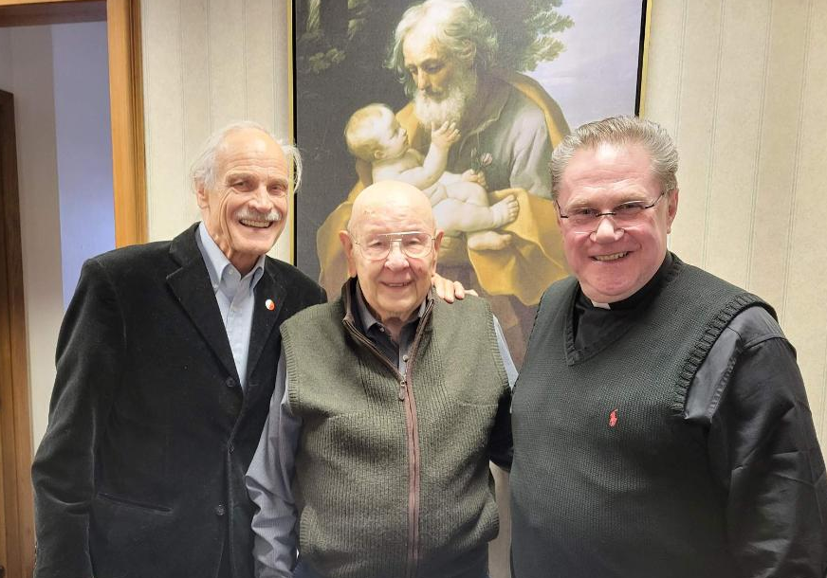
PACT’26 – Meeting #7
Thursday, February 26, 2026 8:00 – 10:47 PM

Participants: Andrzej (NJ), Andrzej (OR),
Halina (LI-NY), Henryk (Cntr.-NY),
Irena (WI), Jacek (DC), Jurek (FL), Piotr (MO),
Ryszard (LI-NY), Tomek (OH), Zbyszek (LI-NY)

Ryszard arranged a meeting with Bishop Andrzej Zglejszewski of the Rockville Center diocese on Long Island. We met with the bishop today at St. Joseph’s Church at 11 AM

What has happened since our last meeting?

- Frank J. Spula has received the prestigious “Man of the Year 2025” award today at the Polish Consulate in Chicago presented by "Dziennik Związkowy" in recognition of his work as President of the Polish American Congress, a position he held from 2005 to 2025.
- Andrzej (NJ), Adam (NJ) and Piotr (MO) will meet with Tomek Kolodziej, chairman of the Church Council, on Saturday at 7 PM.

What we talked about:

- Report from the last meeting was read and commented on.
- Rep. Marcy Kaptur’s resolution. Tomek (OH) and Zbyszek shared their impressions of Marcy.
Kaptur Introduces Resolution Honoring 250 Years of Polish-American Friendship and Reaffirming US Commitment to Poland’s Security | Congresswoman Marcy Kaptur
- President Cioromski's Action Plan. Tomek (OH) did not see any.
- Meeting with Bishop Zglejszewski. He listed churches built by Poles on Long Island (6) and gave us contacts to potential Polonia people who could join PAC-Long Island or help with its activities. Ryszard and Zbyszek learned that there were no plans to close any churches in his diocese.
The problem is the lack of Polish priests, and he asked us for help. For this reason, the church of St. Hyacinth (Św. Jacka) is currently administered by American Pauline monks. We were surprised how little the bishop knew about the activities of Polonia in our area. We left him an "Appeal to Polonia to join the PAC" and envelopes with info about Poland and Polonia.
- PAPA meeting in Cleavland April 13-17. Tomek (OH) found out that he will have a chance to present PAC. It is not known how many priests will attend. Zbyszek suggested distributing envelopes with the info about Poland and Polonia.
- Reparations from Russia. Tusk’s government is working on the report.
- Interview with the US ambassador. It was only mentioned, here is the link:
http://www.facebook.com/reel/1614129576384248
- SAFE (EU Security Action for Europe) – Poland’s €43.7B defense-loan mechanism passes the Sejm. Zbyszek was confused when he read about it in the weekly “Sobota” by Jurek Różalski and internet appeals to the Polish President to veto this bill. None of the meeting participants read
the SAFE document. They formed their opinions based on comments.
- Haym Salomon, mentioned by Prof. Dan Pienkos as another Polish hero alongside Kosciuszko and Pulaski. He was one of the main financiers of the Continental Congress during the American Revolution: Haym Salomon - Wikipedia
- “Szarotka”, Dom Spokojnej Starości in Los Angeles, founded by Pola Negri in 1975. Andrzej (OR) shared with us info: all personnel is Polish, and the house is maintained in the Polish tradition.
It’s worth remembering who Pola was, who gained worldwide fame: Pola Negri - Wikipedia
- Unveiling of Pulaski bust in Saint Louis. Piotr (MO) talked about this initiative of the Polish Cultural Society. The event is scheduled for Saturday, May 16.

What was decided:

- Piotr (MO) will send Jurek a warning to the Republicans re the single citizenship bill.
- Zbyszek will once again send his "Appeal to Polonia to join PAC" to the PACT group.
- Zbyszek will send the recipe for angel wings/faworki/chrust.
Next meeting: PACT’25 > Thursday, March 5, 2026, at 8 PM ET
AGENDA: this report will be read and commented on + current events. zk, 2/27/26

.

PACT’26 – Meeting #8

Thursday, March 5, 2026 8:00 – 11:42 PM

Participants: Andrzej (NJ), Andrzej (OR), Halina (LI-NY), Henryk (Cntr-NY),
Irena (WI), Jacek (DC), Jurek (FL), Mirek (IL), Paulina (south-CA), Piotr (MO),
Ryszard (LI-NY), Tomek (AZ), Tomek (OH), Zbyszek (LI-NY)

What has happened since our last meeting?

- Andrzej (NJ), Adam (NJ) and Piotr (MO) met Saturday at 7 PM with Tomek Kolodziej, chairman of the Church Council, for the first working meeting.
- Andrzej (NJ) prepared a proposal of Agenda for the PAC Church Council.
- Zbyszek sent a link where Polish churches are listed: Polskie parafie w USA – Polonia.net

What we talked about:

- Report from the last meeting was read and commented on.
- Picnic organized by PAC-Arizona. Jola was there and shared her observations with us. The temp. was 92 F but no one seemed to mind. Tents were set up and typical Polish food was sold. It was a strict family event. There were tables, participants were asked to bring chairs. Around 1000 people showed up.
- Pola Negri (Apolonia Chałupiec). Irena heard that someone was making a film about her.
- S. 2914 and H. R 5793, the Eastern Flank Strategic Partnership Act. Oct 24, 2025 · Odds are good that a given bill won’t get passed, but maybe there are ways you can help give it another shot. If you think this bill is not likely to pass in the current session of Congress, how might you try to get it reintroduced in the next one? We wondered why such a pessimistic opinion was issued and why this law would be important for Poland. Tomek (DC) was not present to explain to us.
- The first edition of News from Poland prepared by Tomek Niemyjski, the PAC VP for Polish Affairs.
It was noted that only links to left-wing media were provided. It was suggested to include the EC's
opinions, recommendations, actions on specific issues.
- Polish churches. Andrzej (NJ) presented his plan for the PAC Church Council. Mirek (IL) warned that research should be carried out before trying to help. He mentioned EC's long-standing involvement attempting to save St. Wojciech parish, ultimately learning that the church had only 5 parishioners.
- Why are attachments sent with PACT’26 emails not read? It was suggested to upload them to pCloud.
- Mr. Cioromski's response to Jola’s letter. He was not ask for his opinion.
- Jim Lawicki's recent email on ND Forum regarding Joseph Rej’s behavior.
- An American soldier who saved a Polish comrade. When shrapnel wounded Polish Lieutenant Karol Cierpica in the leg, leaving him unable to move, Sergeant Ollis placed himself between the lieutenant and a suicide bomber, absorbing the blast. On March 2, US President Donald Trump awarded the Medal of Honor to Sergeant Michael Ollis, who was killed in Afghanistan's Ghazni province on 28 August 2013, aged 24. Jola has copies of Cierpica’s book “Ocalony”. Halina mentioned another book by Tom Sileo “I have your back: How an American Soldier Became an International Hero” about the life of Michael Ollies growing up in Staten Island, NY.
- What connects Poland and Italy. Today, Poles play in Italian soccer teams, centuries ago Polish nobility, including Mikołaj Kopernik, studied in Italian schools. Zbyszek intends to mention this in the Brochure.

What was decided:

- During Tuesday's meeting between the EC and Presidents of organizations, we will ask for:
- to begin implementing President Cioromski's ideas contained in his Position Statement,
- to provide the documents that Andrzej (NJ) requested two weeks ago,
- support Piotr’s initiative to abolish the requirement to stop working to apply for a Polish pension.
- To contact our Reps and ask for their support of H. Res. 1082- Recognizing 250 years of Polish American friendship, submitted by Marcy Kaptur.
- Tomek (OH) will send a proposal for the EC to start the procedure of appealing to Polish officials to allow Polonia to have representation in the Polish parliament, as is the case in France and Italy.

Next meeting: PACT’25 > Thursday, March 12, 2026, at 8 PM ET
AGENDA: this report will be read and commented on + current events.
zk, 3/06/26

.

PACT’26 – Meeting #9 Thursday, March 12, 2026 8:00 – 11:36 PM

Participants: Andrzej (NJ), Andrzej (OR), Bogna (NY), Gienek (MO), Halina (LI-NY),
Henryk (Cntr-NY), Irena (WI), Jola (MI), Jurek (FL), Piotr (MO),
Tomek (OH), Wojtek (south-CA), Zbyszek (LI-NY)
We welcomed Bogna, a talented musician, to our meeting tonight.

What has happened since our last meeting?

- The Pilecki Institute branch will open in New York this weekend. This facility - located in Manhattan’s financial district (92 Greenwich Street), in the immediate vicinity of Wall Street, the 9/11 Memorial and the Museum of Jewish Heritage, will function as both an interdisciplinary research center and a cultural and exhibition space.
- Ryszard and Zbyszek received the PAC survey with a month’s delay compared to other divisions.
- On Tuesday, a meeting of the EC with Presidents of organizations took place.

What we talked about:

- Report from the last meeting was read and commented on.
- Pilecki Institute. We welcome the opening of this institution in America. However, the location in lower Manhattan raised questions. The building lease agreement was signed for 13 years.
- How the PAC is organized. It is an umbrella organization bringing together independent organizations, which also include divisions. It seems that the new EC does not understand this.
- PAC Survey by Sylwia (AZ) and Joseph (W-NY). Dissatisfaction was expressed that we have been waiting for months for documents from the EC, but Hubert wants us to send the survey quickly. Zbyszek: we should use this survey to share our observations that could help the PAC leadership.
- Pola Negri (Apolonia Chałupiec). Irena found out that a film had already been made about her.
- Internet Archive: Digital Library. Piotr (MO) told us how to find old websites: Internet Archive: Digital Library of Free & Borrowable Texts, Movies, Music & Wayback Machine
- By-Laws of PAC and divisions. Jola found some interesting statements regarding membership.
- Resolution “Recognizing 250 years of Polish American friendship”. Henryk told us about his initiative to introduce a resolution similar to H. Res. 1082 at the NY State Assembly.
- Bogna's Italian friend. She could possibly help with the Brochure: What connects Poland and Italy. Irena insisted on including the Dąbrowski Legions and Jan Kochanowski (called the Polish Petrarca in Italy).
- Historic elections at PAC. For the first time, a President was elected who did not also serve as President of the PNA. This arrangement has worked well in the past, when the PNA supported PAC financially, but in recent years this support has ceased. Wojtek (south CA): the main financial blow to the PAC came in 1992 following NDS' fated decision to transfer funds to the newly formed PAC Charitable Foundation that was to cooperate with PAC. It soon turned out that this was just wishful thinking.

What was decided:

- Zbyszek will send Tomek Niemyjski suggestions regarding the "News from Poland" to include links to independent and patriotic media - not only to the mainstream media. Furthermore, including opinions, recommendations and proposed actions of the EC’s would significantly enrich this important initiative.
- Zbyszek reminded us to contact our local Reps and ask for their support for H. Res. 1082 -
“Recognizing 250 years of Polish American friendship”, submitted by Marcy Kaptur.
- Piotr (MO) asked us to send emails supporting his initiative to abolish the requirement to stop working in order to receive a Polish pension to Agnieszka Jędrzak - Minister for Polonia Affairs in the Chancellery of the President of the RP. He will send us a sample letter.
- Heniek (Central NY) inspired others to follow his example and submit a resolution in their states commemorating the 250th Anniversary of Polish American friendship.
- Zbyszek will contact Jim Lawicki and help him file a complaint against Joseph Rej.
- Irena (WI) will try to get us a film about Pola Negri.
- We should all re-examine the PAC By-Laws and ours and, where necessary, propose improvements.
- Those divisions that support Wojtek’s letters should start informing him about it.

Next meeting: PACT’25 > Thursday, March 19, 2026, at 8 PM ET
AGENDA: this report will be read and commented on + current events. zk, 3/13/26

.
.
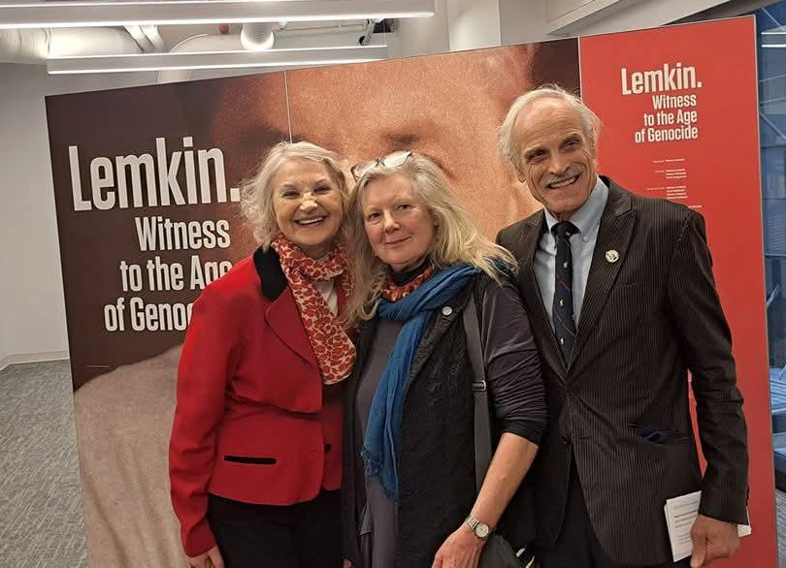
PACT’26 – Meeting #10
Thursday, March 19, 2026
8:00 – 10:38 PM

Participants: Andrzej (NJ), Andrzej (OR), Gienek (MO), Halina (LI-NY),
Edmund (PL), Irena (WI), John (TX),
Jola (MI), Jurek (FL), Piotr (MO),
Tomek (OH), Wojtek (south-CA), Zbyszek (LI-NY)

Edmund after a long absence from our meetings connected with us from Warsaw. Hubert’s recent actions inspired him to join us today.

What has happened since our last meeting?

- Halina, Krystyna and Zbyszek were present at the opening of the Pilecki Institute (photo above).
- Only Jurek (FL) and Tomek (OH) sent emails to Agnieszka Jędrzak re the draft of pension law.
- NDs meeting was scheduled with Elections and By-laws amendments via Zoom for June 20.
- Hubert Cioromski, President of PAC summarized the recent EC activities in a video recording.
- The EC sent its “Communication Policy” via the ND Forum.

What we talked about:

- Report from the last meeting was read and commented on.
- Igor Janke. John (TX) told us about his visit to the Polish Heritage Center in Panna Maria. John was very impressed with him, introduced him to several EC members and recommended that he be invited to a PACT meeting. https://pl.wikipedia.org/wiki/Iof PAC gor_Janke
- Pilecki Institute. The drive from Foral Park took 2 hours due to traffic and parking cost was $100. Krystyna came from Connecticut by train. In addition to participating in this important event, it was worth coming to meet old friends and make new ones. The conversation with Minister, Jan Dziedczak, was interesting. There was no one representing PAC EC.
- PAC initiative aimed to limit the political involvement of divisions and redirect their activities towards organizing cultural, educational, and artistic events. A requirement to notify the EC about planned actions was also introduced. The EC wants to have total control over the divisions. Jola suggested writing a short response: that we do not agree with their demands which are unconstitutional. Tomek (OH) proposed that we write what we expect from the EC. Zbyszek’s suggestion to write one joint letter to be signed by the divisions that agree with it, was rejected. Instead,
Andrzej’s idea of writing separate emails via ND Forum was adopted.
- PAC Survey. Jola provided partial answers. Irena (WI) and Tomek (OH) have not filled it out yet.
- Polish group at the St. Patrick's parade in Cleaveland. Tomek (OH) recorded a short film that was viewed by 25 k people on Facebook. He mentioned comments reviling a lack of knowledge about
the Polish flag with the eagle and surprising negative comments from Poland.
- Piotr’s (MO) initiative. Edmund (PL) confirmed that this law should be waived, but this will not be easy.
- Irena (WI) told us that in her 2 years as President she managed to double the number of division members. She is having trouble getting the password to the Division's Facebook account from the person who created it and left. Most of their maturer US-borne members are politically disoriented.

What was decided:

- Zbyszek will prepare a draft of what divisions expect from the EC.
- Tomek (OH) recommended putting your own picture on PAC business cards.
- Zbyszek will try to get the password to PAC-WI Facebook.

Next meeting: PACT’25 > Thursday, March 26, 2026, at 8 PM ET
AGENDA: this report will be read and commented on + current events.
zk, 3/20/26

.

PACT’26 – Meeting #11
Thursday, March 26, 2026
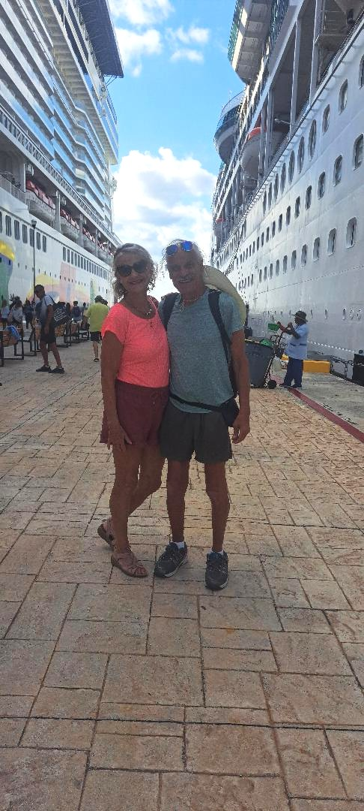
8:00 – 10:38 PM

Participants: Andrzej (NJ), Andrzej (OR),
Irena (WI), Jola (MI), Krzysiek (IL),
Jurek (FL), Piotr (MO), Mirek (IL),
Tomek (OH), Zbyszek (LI-NY)
The first PAC integrational trip initiated by Jola (MI). Destination - western Caribbeans - suggested by Halina (LI-NY). Thanks to Jola, the trip was widely advertised. Jurek (FL) negotiated a special group offer. The weather was great and we had a great time on
the ship and during the excursions.
We had many interesting conversations.
27 people from Michigan, mostly from
the local PAC division took advantage
of this unique opportunity.
Thank you, Jola, for this initiative!
More about the trip:
The Norwegian Cruise Line “Encore” departed from Miami and called at Belize (NCL private island), Roatan (Honduras), Costa Maya and Cozumel Mexico). There were 4 600 passengers on board, including only 1 300 tourists from the US, and 1 600 crew members. The cafeteria during breakfast was crowded. Next time we will try to find a smaller ship. As for the shows, the best entertainment was “Beatles Invasion” (three concerts).

At the time of the meeting, Jola (MI), Halina and Zbyszek (LI-NY) were on a ship sailing from Cozumel (Mexico) to Miami. Zbyszek joined the meeting late and had a problem with the speaker, which he managed to fix and finally (after 8:40 PM) listened to the conversation. However, despite numerous attempts, he could not turn on the microphone, preventing him from participating in the discussion. He could only listen for an hour and half (his internet time). We would like to thank Andrzej (NJ) for moderating the meeting.

What was discussed:

- Zbyszek’ proposal regarding Communication Policy from the point of view of the Presidents of PAC divisions. Suggestions for improvements were made.
- Mirek’s proposal to support the Chicago Holocaust Museum in their efforts to receive government funding. This topic inspired Andrzej (OR) and Tomek (OH) to recall positive and negative episodes from the history of Polish Jewish relations. Jews were part of the Polish social mosaic, and they were treated the same as any other ethnic group. This situation changed after the invasion of the Soviet Union in !939 when Jews began collaborating with the NKWD, taking actions against Polish Catholics. Saving Jews required risking the lives of not only a rescuer but also of his family and neighbors. After WWII the Soviets appointed Jews to government positions including infamous UB (Security Office) responsible for the murder of Polish patriots. It is worth remembering these facts in conversations in which Poles are accused of anti-Semitism.
- By-Laws of PAC divisions. Once again, it was reminded of the need to analyze the documents of your division and amend them to ensure that PAC membership does not compromise the division's independence.
- NDs meeting via Zoom on June 20. As we know, PAC Vice President, Mr. James Robaczewski resigned, therefore, elections are planned, as well as the possibility of amending the By-Laws.
Next meeting: PACT’26 > Thursday, April 2, 2026, at 8 PM ET
AGENDA: this report will be read and commented on + current events. zk, 3/28/26

.

PACT’26 – Meeting #12
Thursday, April 2, 2026
8:00 – 12:12 PM

Participants: Andrzej (NJ), Andrzej (OR),
Halina (LI-NY), Irena (WI), Jola (MI),
Piotr (MO), Mirek (IL), Tomek (OH),
Wojtek (south CA), Zbyszek (LI-NY)

<-- Example of exceptionally well designed
holiday wishes by Sylwia (AZ)

What has happened since our last meeting?

- On Tuesday Oct. 14, Mr. Niemyjski and Mr. Kolodziej scheduled the monthly meeting of the EC with Presidents of PAC organizations.
- Piotr (MO) posted his initiative on ND Forum twice to waive the requirement to stop working to receive a Polish pension. There was no response from the EC and NDs.
- Zbyszek sent the “Communication Policy”, refined by Ryszard, to the Presidents of PAC divisions, asking them to sign it.
- The EC sent Presidents of PAC organizations a provisional budget, dated 3/24/26.
- Zbyszek sent a report on Polish churches on Long Island to Ryszard (LI-NY) for review.

What we talked about:

- The Reports from the two previous meetings were read commented on and corrected.
- The Holocaust Museum in Skokie, north of Chicago. Mirek explained that a separate room will be dedicated to Polish martyrdom and Poles who risked their lives to save Jews. Most participants were skeptical about the museum's good intensions and recommended close monitoring of its plans. Zbyszek expressed concern about the PAC reputation if, after supporting their request for funds, the museum invites Prof. Gross or any another researcher with anti-Polish views.
- Zbyszek reminded about signing the Communication Policy from the perspective of the Presidents of PAC divisions. Several presidents present at the meeting requested their divisions be included.
- Recent EC Statement on the visit of Russian parliamentarians on the behalf of the PAC. The visit was organized by Republican Rep. Anna Paulina Luna Wikipedia, the free encyclopedia.
- The mysterious disappearance of Mr. Jams Robaczewski from the EC. No one could explain it.
- How to increase the number of division members. Irena (WI) achieves this by organizing events. During her two years as president, she managed to double division’s funds.
- How to fight accusations of anti-Semitism. Tomek (OH) suggested some questions worth asking:
Do you accuse the French the same way that, unlike the Poles, they sent trains with their Jews to concentration camps? Do you know that anti-Polonism existed in the US?
- The Importance of teaching History. According to Tomek (OH), this is the most important subject, shaping identity and awareness of the future person - we all agreed with that.
As we know, the current Polish government is seeking to restrict the teaching of history.

What was decided:

- PAC-IL would be the best choice to represent PAC in its support of the Skokie Holocaust Museum. They operate locally, so it will be easiest for them to establish close cooperation with the museum.
- To prepare, as soon as possible, for the NDs meeting, scheduled on Zoom on June 20.
- Irena (WI) planes to establish a Polish affairs team in her division on April 15.
Next meeting: PACT’26 > Thursday, April 9, 2026, at 8 PM ET
AGENDA: this report will be read and commented on + current events. zk, 4/4/26
.
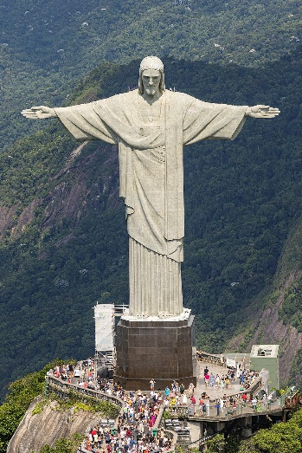
PACT’26 – Meeting #13 Thursday, April 9, 2026, 8:00 – 10:15 PM

Participants: Andrzej (NJ), Andrzej (OR), Gienek (MO), Halina (LI-NY),
Heniek (Cntr NY),Irena (WI), Jola (MI), John (NJ), Jurek (FL),
Mirek (IL), Paulina (South CA), Piotr (MO), Tomek (OH),
Wojtek (south CA), Zbyszek (LI-NY)
One of Paulina’s stops in Brazil. Christ the Redeemer Christ the Redeemer is a stone and concrete statue of Jesus in Rio de Janeiro, created by Polish sculptor Paul Landowski and built by Brazilian engineer Heitor da Silva Costa, in collaboration with French engineer Albert Caquot. The face was carved by the Romanian sculptor Gheorghe Leonida. Built between 1922 and 1931, the statue is 30 meters (98 ft

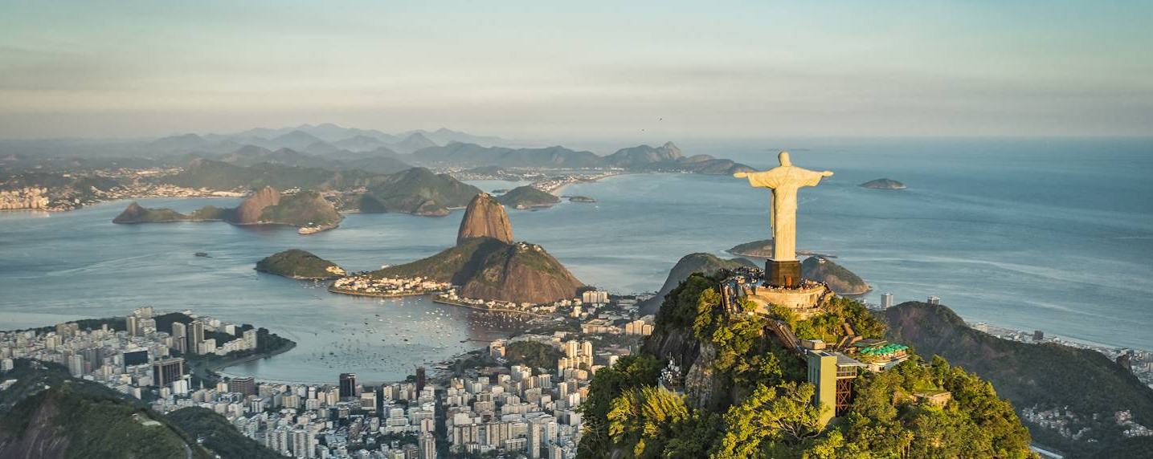

What has happened since our last meeting?

- On Tuesday, Zbyszek drove Ryszard to the monthly meeting of the Pulaski Association of Business and Professional Men (est. 1959) which was held in P&S Center in Greenpoint. Zbyszek was impressed by the professionalism with which the meeting was conducted. Members had the opportunity to express thier opinions on issues, without time pressure, and decisions were made by voting. Surprisingly, there is no interest in joining PAC-LI or NY Downstate divisions.
- Piotr (MO) has not received a response from either the EC or NDs even though he posted on ND Forum for the 3rd time his initiative to waive the requirement to stop working to receive a pension.

What we talked about:

- The Report from the last meeting was read and commented on.
- The Holocaust Museum in Skokie. Mirek (IL) informed us that the Illinois division, and he, will establish cooperation with the museum. Zbyszek mentioned two exhibits owned by the Long Island division: “Auschwitz” and “They risked their lives” which are available for rent.
- Communication Policy from the perspective of the Presidents of PAC divisions. Andrzej wants to approach the EC's Policy in his own way. He asked to be removed from the list of signatories.
- Lukasz Dudka's dependence on funds from Poland, a possible conflict of interest, was discussed.
- Brazil and its attractions. Paulina shared her recent trip to several exciting places: from Manaus, through waterfalls, the Amazon Forest (4 days) to Rio dr Janeiro. She recommended using Uber.
- Next cruise. Jurek (FL) told us about the options. Halina (LI) shared what we can expect. Mirek (IL) attended the unveiling of the Ralph Modjeski plague in Nenana on July 15, 2023, held on the 100th anniversary of the opening of the famous Mears Memorial Bridge.

What was decided:

- Jurek (FL) asked for a $50 donation to be given to a church in Kazakhstan for planting trees and supporting the Polish school operating there.
- Analyzing which proposals for changes to the By-Laws make sense.
- Irena (WI) will send us a link to photos from traveling exhibition devoted to Auschwitz.
Next meeting: PACT’26 > Thursday, April 16, 2026, at 8 PM ET
AGENDA: this report will be read and commented on + current events. zk, 4/10/26

PACT’26 – Meeting #14 Wednesday, April 15, 2026, 8:00 – 11:20 PM

Participants: Andrzej (NJ), Andrzej (OR), Halina (LI-NY), Jola (MI), Mirek (IL) connected from Los Angeles, Piotr (MO), Ryszard (LI-NY), Tomek (OH), Wojtek (south CA), Zbyszek (LI-NY)
The meeting was rescheduled to Wednesday due to several requests made a few hours earlier.

What has happened since our last meeting?
- On April 11 (Saturday), Zbyszek sent the “Communication Policy from the perspective of division Presidents” signed by the Presidents of 7 divisions: Long Island, Michigan, Ohio, Florida, Eastern Massachusetts, Missouri, Northern California and by the President of PAC of Southern California.
- After Zbyszek posted the Policy proposal on ND Forum, Tomek (DC) sent his division’s “Position on the proposed Communications policy”, which was welcomed by John (CT), Zbyszek and Ryszard (LI).
- On Saturday, Halina, Ryszard and Zbyszek (PAC-LI reps) took part in the “Man of the Year” gala organized by the Pulaski Association of Business and Professional Men. Nearly 300 people participated. A Polish parliamentarian and Polish Consul were present. An impressive journal could fetch $50 k. Tickets cost $250 per person. The music was good but way too loud.
- On April 12, Andrzej (NJ) posted Biniecki's article “Plan for PAC”. Only Zbyszek reacted.
- On April 13, Zbyszek sent an “archaeological discovery” to ND Forum, which was found in one of his boxes of documents, which was a summary of ideas for the revitalization of PAC, dated 2017.
- On April 14 at 6 pm, Halina & Zbyszek attended a lecture by Anna Jaroszynska Kirchmann "American Polonia resources for history" based on the book "Polish American Voices,
a Documentary History, 1608-2020" - which took place at the Pilsudski Institute in Greenpoint.
- On April 14 at 8 PM ET, the monthly meeting of the presidents of PAC org. and the EC was held.
- Piotr (MO) talked with the President of PASI, Dr. Gene, about the activities re Polish pension.

What we talked about:
- The Report from the last meeting was read and commented on.
- The bridge between Queens and Brooklyn. The Pulaski Association of Business and Professional Men played a role in preserving the name Kosciuszko Bridge. Ryszard (LI) recalled how in 1939, when he was 8, he witnessed the opening of this bridge.
- Donations to American organizations from Poland. Wojtek (s. CA): "It is unethical and downright ridiculous that we live in the richest country in the world and yet we ask for money from Poland."
- Where was the PAC registered, in NY (the first meeting was held in Buffalo) or in Illinois.
- Grant for the Copernicus Foundation to improve PAC: a surprising and interesting discovery on
the Polish Senate website. Wojtek (south CA) reminded us: "Only non-profit organizations receive donations, which is why the creators of “Flavor of Poland” never received them."
- Monthly meeting led by two Tomeks. Shortly after Mr. Cioromski joined us, a heated argument broke out over Leszek's discovery of funds transferred from Poland to PAC. Tomek (DC) rightly and quickly interrupted the meeting, after just 30 minutes. Right after the meeting Lukasz, PAC VP for PR, sent an opinion from a law firm re donations from abroad, confirming Wojtek's concerns.
- Threats to Poland. Mirek (IL) wondered how we can warn the public and politicians in Poland. Wojtek (south CA): “His recent letters may play a similar role as in case of S.477.”
- Who would be a good candidate for the position of first VP. Several names were mentioned.
- The new organization “Zryw” of Alexander, son of Radek Sikorski. There is strong suspicion
that its aim will be to indoctrinate young people.

What was decided:
- Piotr (MO) kindly asked us to post the following announcement on our social media:
The Unveiling Ceremony of the GENERAL CASIMIR PULASKI MONUMENT will take place on Saturday, May 16, 2026, from 12:00-2:00pm. The monument will be placed at the Powder Magazine Plaza of the Jefferson Barracks Park in St. Louis County. You are all invited!
- Zbyszek (LI) recalled co-signing Wojtek’s (south CA) letters re threats to Poland.
- Piotr (MO) reminded about sending the petition re the Polish pension.
- Jola (MI) will prepare a list of organizations that received donations from Poland.
- Wojtek will prepare complaint documents.
- Zbyszek will prepare a proposal to finance the celebration of the 250th Anniversary of Friendship between Poland and USA, which is planned to take place in Washington.
Next meeting: PACT’26 > Wednesday, April 22, 2026, at 8 PM ET
AGENDA: this report will be read and commented on + current events. zk, 4/17/26
.

PACT’26 – Meeting #15 Wednesday, April 22, 2026, 8:00 – 10:47 PM

Participants: Andrzej (NJ) connected from Poland, Andrzej (OR), Halina (LI-NY),
Henryk (Ctr. NY), Irena (WI), Jola (MI), Marek (MO), Paulina (south CA), Piotr (MI),
Ryszard (LI-NY), Wojtek (south CA), Zbyszek (LI-NY).
The meeting was rescheduled again to Wednesday because Halina and I had plans for Thursday.

What has happened since our last meeting?

- PAC President Hubert Cioromski and National Secretary Lukasz Dudka visited PAC-WI at their Wednesday's membership meeting. Hubert announced that he would like to join Wisconsin division since he is moving from Chicago. Lukasz talked about grants from Poland. PAC-WII members were impressed by their presentations.
- April 20. Mr. Cioromski posted a document on the ND Forum.re "non-compliance with the rules".
- Jola (MI) and Irena (WI) were reelected as Presidents of their divisions for another 2-year term.
- PAC-LI received an invitation from Jola Wodiczko to support an event celebrating the 250th Anniversary of the founding of the US, which will take place on July 11 at the Kaufman Center.
- Jola proposed changes to the By-Laws regarding Directors-at-Large and the duties and obligations of the PAC President.

What we talked about:

- The Report from the last meeting was read and commented on.
- Non-compliance document. We wondered what the PAC President wanted to achieve by indiscriminately attacking all organizations instead of reprimanding the few that did not comply.
We felt offended. Some suggested reacting, others ignoring the matter. Relevant excerpts:
Following the recent survey distributed to all Divisions and the responses (or, in many cases, the lack of responses) we received, it has become clear that several Divisions are not fully meeting their obligations under the National Bylaws of the Polish American Congress.
Therefore, I am writing to formally put your Division on notice: your Division is currently not in compliance with the National Bylaws of the Polish American Congress. As required by Article VI, Section 2, please submit to the PAC National Secretary the following:
A certified copy of the Articles of Incorporation
Current bylaws
Annual corporation report
Annual Treasurer’s report
Complete membership report
This letter shall serve as official 30-day notice for your Division to come into full compliance. Within the next thirty (30) days, please take all necessary steps to address any outstanding obligations and fulfillment of all other responsibilities outlined in the Bylaws. Polish American Congress.
Should your Division fail to achieve full compliance within this 30-day period (by May 20, 2026).
The National Executive Committee reserves the right to take further action as provided under the Bylaws, to protect the integrity of the organization.
- Concerns related to the grants (at least 1.45 million PLN, for 2025-27) awarded by the Senate to the Polish-American Agenda of the Copernican Foundation for the "restructuring and professionali-zation of PAC”, as well as grants awarded to “Dziennik Związkowy” under the leadership of Łukasz Dudka. Such donations risk compromising the PAC's independence and may be illegal.
- May 3rd Constitution Day. Irena (WI) is busy preparing for this event at the Capitol in Madison.

What was decided:

- Jurek (FL) reminded us about sending him $50 for the initiative of a Polish priest in Kazakhstan who intends to commemorate the 90th anniversary of the deportation to Siberia by planting trees. Donors will be honored with plaques bearing their names.
- To collaborate to prevent the destruction of PAC – we will discuss ways to achieve this goal.
- Zbyszek (LI) will send to the PACT group the PAC-LI oaths intended for members.
- Jola (MI) will send us proposals for changes to the By-laws submitted by her division.
- Wojtek will prepare a list of donations from the Senate to organizations affiliated with PAC.
Next meeting: PACT’26 > Thursday, April 30, 2026, at 8 PM ET
AGENDA: this report will be read and commented on + current events. zk, 4/24/26
.

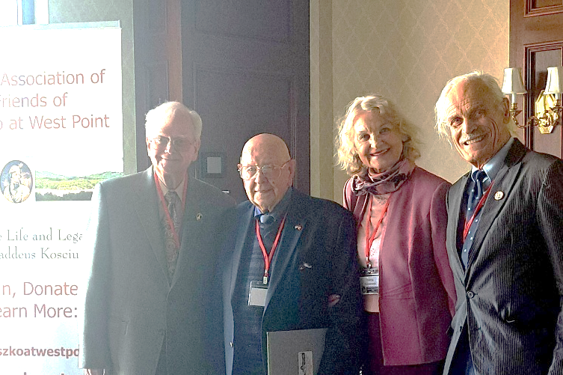
PACT’26 – Meeting #16
Thursday, April 30, 2026, 8:00 – 11:00 PM

Participants: Andrzej (OR), Gienek (MO), Halina (LI-NY), Henryk (Ctr. NY), Jola (MI), Jurek (FL), Piotr (MI), Wojtek (south CA), Zbyszek (LI-NY).

At West Point with Prof Tony Bajdek, former PAC VP for American Affairs, Ryszard, Halina and Zbyszek.

What has happened since our last meeting?

- On Friday, Halina, Ryszard (with his son and grandson) and Zbyszek took part in a Conference, (which has a 33-year tradition) organized by Prof. Anthony Bajdek, co-founder of the "Friends of Kosciuszko at West Point". It was a treasure trove of interesting stories and information presented by 18 speakers.
- On Saturday, Ryszard and his family stayed overnight and joined Henryk for a ceremony at
the Kosciuszko monument, attended by 100 people.
- On Sunday, Halina and Zbyszek went to a performance of “Mazowsze” at a college in Brooklyn.

What we talked about:

- The Report from the last meeting was read and commented on.
- Unveiling of the bust of Pulaski. Gienek: Until now in Saint Louis we only had a monument to John Paul II. The event will take place at Jefferson Barracks Park at 12 noon. In addition to Krzysiek Waz (IL), Ambassador Klich is expected to be present.
- Poland’s investment in weapons. Wojtek mentioned several transactions: 366 Abrams tanks (250 new and 116 modernized) for $7billion and 980 south Korean K2s tanks, 648 self-propelled K9 armored howitzers, and 48 FA-50 fighter jets, for $6.7 billion. Wojtek disagrees with John Czop, who proposes that PAC should lobby for a better deal. He believes that instead of buying expansive tanks, which can be easily destroyed by cheap drones - Poland should invest in
the design and production of drones and hypersonic missiles that cannot be intercepted.
- The two-day event at West Point. Halina and Heniek told us about their very positive impressions.
- Funds for PAC from Poland. We discussed how Wojtek’s summary should be presented to NDs. The documents clearly state that PAC is the beneficiary. According to Gene (MO) the organization must first spend its own money and then; by submitting invoices it will receive the promised money from Poland. Others, however, argued that the organization would receive the money before it starts spending. Jola would like to ask the Senate whether PAC has ever asked for donations.
- When and how many times per year should a division provide its documentation to the EC? At
the beginning of the year, after June 30th or before the ND meeting? No one could give an answer.
- Jola’s discovery: Art. IV, Sec. III, Powers and Duties of Secretary. Item a) To record or see to the proper recording of the minutes and transactions of all meetings of the Executive Committee, and Council of National Directors, and to maintain separate minute books at the principal office of the corporation, or such other place as the Council of National Directors may order, of all such meetings in the form and manner required by law; So, we have rights to ask for minutes of the EC.
- Folk group “Mazowsze”. Halina summarized the 4-hour performance which delighted her.

What was decided:

- Jurek (FL) reminded us again to send him $50 for the project in Kazakhstan, and to provide a text we want to put on the commemorative plaques. This is the last week we can participate in this campaign.
- Zbyszek (LI) suggested preparing two parts of the letter about funds from Poland, which is planned to be published on the ND Forum: one short version and the other with more details.
- To ask about EC's plans for the current year and its actual budget during the monthly meeting.
Next meeting: PACT’26 > Thursday, May 7, 2026, at 8 PM ET
AGENDA: this report will be read and commented on + current events. zk, 5/03/26

.

PACT’26 – Meeting #17

Thursday, May 7, 2026

8:00 – 11:00 PM

Participants:

Andrzej (OR), Gienek (MO), Halina (LI-NY),
Irena (WI), Jacek (DC), Jola (MI),
Jurek (FL), Marek (MO), Mirek (IL), Paulina (SCA),
Piotr (MO), Piotr (MI), Ryszard (LI, NY),
Wojtek (south CA), Zbyszek (LI-NY).

What has happened since our last meeting?

- Jurek (FL) informed us that his PAC division held a successful meeting with Przemyslaw Czarnek who aspires to become the next Prime Minister.
- Polish airline LOT launches new connections to Phenix, Washington, Boston, San Francisco.
- 20 people responded to the project in Kazakhstan in which Jurek (FL) is involved.
- On Sunday, Halina and Zbyszek took part in 3 events: a meeting of congressman Tom Suozzi volunteers, a film screening in the Holocaust and Tolerance Center and celebration of the May 3rd Constitution. This was possible because all these events took place in Glen Cove, Long Island and began one after the other, starting at noon.
- On Sunday PAC divisions celebrated the Constitution of May 3rd.

What we talked about:

- The Report from the last meeting was read and commented on.
- 90th anniversary of the deportation to Siberia. Jurek (FL) reminded us to send checks for $50 with the name we want to commemorate. And that we can visit this place, perhaps next year.
- Who could replace Tomek Kolodziej as VP for American Affairs. Tomek’s (DC) resignation is a serious blow to our organization. It will be difficult to find someone so dedicated and competent.
- Funds from Poland for PAC. To avoid complications, the easiest way is to return them.
- John Czop’s strange behavior - instead of looking for common ground, he fuels discord. Apparently, someone had slipped to him a complaint against Wojtek (SCA), John claimed (as it was missing a date and signature) that it was prepared in 2020, by the then First VP, Mr. Pierchalski. Zbyszek attended the NDs 2016 meeting in Chicago and is also familiar with issues related to S.447, which are subject of this complaint, was shocked by the lies in this “document”.
- May 3 celebrations in various divisions. Irena (WI) prepared the most spectacular event at the Capitol in Madison near Liberty Bell. Among other things, the Governor’s proclamation was read. Mr. Cioromski also spoke. Around 100 people took part in the ceremony. Tomek (OH) will share photos from their parade. Jola (MI) reported that they had a special mass, lunch and 5k run. About 300 people took part, including local scouts.
- Parishes in Michigan. Jola (MI) learned from the priest that there are 219 parishes in Michigan. The lack of priests forces the diocese to consolidate services provided in churches. This will apply to every parish, not only Polish ones. Information meetings for parishioners have begun. We wondered what would happen with the Committee which was initiated by Tomek (DC).

What was decided:

- Wojtek (SCA) will prepare a letter informing about the risks associated with PAC accepting funds from Poland. Mirek (IL) suggested, and Zbyszek supported him, to reach out to NDs through the Presidents of the organizations.
- Not to respond to the lies contained in the “grievance” posted by John (NJ) on the ND Forum.

Next meeting: PACT’26 > Thursday, May 14, 2026, at 8 PM ET
AGENDA: this report will be read and commented on + current events. zk, 5/08/26


PACT’26 – Meeting #18
Thursday, May 14, 2026
8:00 – 11:07 PM

Participants:
Andrzej (OR), Bill (N-CA),
Gienek (MO), Halina (LI-NY),
Heniek (Ctr-NY), Jacek (DC),
Jola (MI), Jurek (FL), Mirek (IL), Paulina (SCA), Piotr (MO), Wojtek (south CA), Zbyszek (LI-NY).

PAC-LI is involved in this event.
Anyone interested please contact us:
516 – 354 4349 718 -343-4316

What has happened since our last meeting?

- Krystyna (CT) recommended reading “The spiritual History of Poland” by Grzegorz Górny.
- On May 2, Dr. Mark Pienkos interviewed Zbyszek (LI) about PAC-LI. ZK was surprised because his division returned completed survey and answered follow-up questions from the PAC VP for PR.
- Tomek's (OH) son took photos from the May 3rd Parade, and they should be published soon.
- On Tuesday, Mr. Niemyjski led the monthly meeting of the EC and presidents of organizations. Instead of discussing Polish and American affairs, as was planned, we talked about the potential risks posed by donations from Poland. Ryszard (LI) proposed the establishment of a committee to deal with this matter.

What we talked about:

- The Report from the last meeting was read and commented on.
- Candidate for VP for American Affairs. Zbyszek recommended Jacek (DC). He is convinced that Jacek would be a good successor to Tomek (DC). He is from the Washington area which is a plus.
- Mr. Adasiewicz, Mr. Jesman and Mr. Kacki will check whether money from Poland for c4 org. are OK.
- Trip to the National Parks of the Southwest. Piotr (MO) waited many years for permission to get to these special places. He visited: Wave Canyon, Lower Antilope Canion, Balance Rock, Capitol Reef, Bryce. He traveled 4200 miles in 2 weeks. He promised to share his photos.
- Polish masses. Heniek (Ctr-NY) shared with us a problem with their bishop who does not allow mass to be celebrated in Polish, even though there are 3 Polish priests in the parishes. Gienek (MO) suggested contacting the Bishop in Poland who is responsible for helping the Polish diaspora. He also mentioned that much depends on how well the parishioners are organized.
- John Czop’s strange behavior. Andrzej (NJ): during his division meeting on Monday, John was asked why he was so aggressive towards Wojtek (S-CA). He gave no explanation.
- How to make transfers from Polish banks – Heniek (MO) had problems. Halina (LI) explained: You should ask whether a given bank in Poland sends codes abroad. Next, you need to check if your mobile carrier accepts these codes (for example, ATT did not, but T-Mobile did).

What was decided:

- Gienek and Piotr from PAC-MO reminded about Saturday's unveiling of the Pulaski bust in Saint Louis.
- To contact Klara Wisniewski - as suggested by Paulina (S-CA) .
- Andrzej (NJ) will tell us about his trip to Poland and Turkey at the next meeting.

Next meeting: PACT’26 > Thursday, May 21, 2026, at 8 PM ET
AGENDA: this report will be read and commented on + current events. zk, 5/17/26

PACT’26 – Meeting #19 Thursday, May 21, 2026 8:00 – 11:22 PM

Participants: Andrzej (NJ), Andrzej (OR), Bill (N-CA), Gienek (MO), Halina (LI-NY),
Heniek (Ctr-NY), Irena (WI), Jacek (AZ), Jacek (DC), Jola (MI), Jurek (FL), Krzysiek (IL),
Paulina (SCA), Piotr (MI), Piotr (MO), Roman (DC), Wojtek (south CA), Zbyszek (LI-NY).

Tom Payne, ND Forum: Memorial Day (It is observed on the last Monday of May) was established in 1868 at the end of the Civil War. It recognized the lives lost in that conflict (800,000), which is more than the combined total of American lives lost in World Wars I and II. Polish Americans fought for both Union and Confederacy, and it is noteworthy that the first soldiers killed in the Civil War were both Polish: Captain Constantin Blandowski for the Union and Thaddeus Strawinski for the Confederacy. Vladimir Krzyzanowski commanded a US regiment known as the Polish Legion.

What has happened since our last meeting?

- The President of PAC, Mr. Hubert Cioromski sent a message to the organizations' Presidents on Wednesday at 10:19 AM ET. The subject of his email was: Urgent call Thursday 5:00pm central.
- 24 people attended the meeting at 5 pm CT: 10 divisions' Presidents, as well as Presidents of PAC South California and Falcons (Mr. Kuzma), six EC officers, and Directors at Large
- Jacek Marczynski was elected President of the Washington DC division.

What we talked about:

- The Report was not read because participants were discussing issues related to PAC funding.
- Funds from Poland for Polonia projects. Jacek (AZ) explained the whole process in detail. Non-profit organizations that submit the application on behalf of the Polonia organizations must be registered in Poland. They keep 10-18% of approved funds for themselves.
- Why funds from Poland pose a threat to our organization and what we can do to save PAC. There was a lively discussion. Some suspected that the current Polish government was trying to bribe the PAC or destroy it.
- The PAC meeting at 5 PM. I was not present, so I am quoting opinion of Jola (MI), with her permission, posted on ND Forum on May 22: Dear National Directors,
Yesterday, a group of us (about 22+, PAC presidents, National Directors and the Executive Committee) was invited to and participated in a meeting which President Cioromski described during the meeting as “informal,” and therefore, according to his statement, no minutes would be taken.

During the meeting, we heard details regarding the EC decision to apply for and receive funds on behalf
of PAC, reportedly for the first time in the 82-year history of our organization, in the form of a grant from the Senat of RP. The subject discussed was extremely important to our organization.

The way the information was presented, as well as the attitude and tone directed toward the invited participants, was inappropriate and concerning. During the discussion, fellow members were referred to with terms such as “liars,” “organizational fear mongers,” and some of us accused of “spreading misinformation.” Such language is divisive, unprofessional, and not conducive to respectful dialogue.
This gathering was not a social event and, in my opinion, should have been treated as an official meeting.
We are a nonprofit Polish American advocacy organization governed by the laws of the US. As a federal organization, meetings during which important organizational, political, financial, or governance matters are discussed should be conducted formally and properly documented with written minutes.
As President of PAC-MI, I insist that all meetings involving official organizational matters be properly recorded with written minutes maintained as part of the organization’s records.
I have decided that I will not participate in informal sessions, meetings, or similar gatherings where official organizational matters are discussed without proper procedure, professionalism, and recordkeeping.
Respectfully, Jolanta Halaczkiewicz, President PAC-MI

What was decided:

- To file a complaint regarding the conduct of some participants during the PAC meeting on May 21.
- To prepare a disclaimer regarding Senate approved funds for PAC.

Next meeting: PACT’26 > Thursday, May 28, 2026, at 8 PM ET
AGENDA: this report will be read and commented on + current events. zk, 5/23/26

